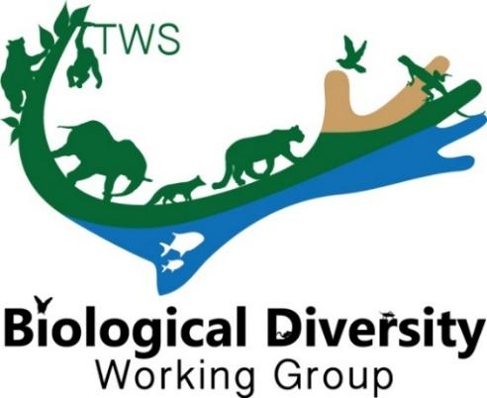
THE WILDLIFE SOCIETY
BIOLOGICAL DIVERSITY WORKING GROUP

The Biological Diversity Working Group (BDWG) is offering Student Travel Grants (up to $500) to help students attend the 2026 TWS Annual Conference in Des Moines, Iowa, USA. Be sure to apply no later than August 2nd, 2026. Email us at twsbdwg@gmail.com if you have any questions.

Eligibility
All applicants must be a member in good standing with The Wildlife Society (but are not required to be a member of the BDWG) and have been accepted to present a paper/poster at the 2026 TWS Annual Conference. This is a merit-based award that will be scored based on the categories: 1) contact information, 2) abstract, 3) membership, 4) involvement, and 5) relevance.

**APPLICATION:
Submit application, as a PDF file, directly to the BDWG (twsbdwg@gmail.com) no later than August 2nd, 2026. Place “Student Travel Grant Application” in the subject line of the email.

Contact Information
Date of Application:
Student’s Name:
Institution and Address:
Phone:
E-mail:
Abstract
Presentation Title:
Authors:
Current Category:
Presentation Type:
Abstract:
Membership (Please state if you [the student] are a current member of the Biological Diversity Working Group; BDWG membership is not required, but applications from a member will receive priority. You can join BDWG anytime via your TWS Member Portal.):
Involvement Please explain how you plan to be involved with Biological Diversity Working Group activities during the 2026 TWS meeting and beyond; for example, attending the BDWG annual meeting and/or sponsored symposia/workshops, nominating yourself or others for a board position, sharing content for our Instagram (@tws_bdwg) and newsletters, attending the monthly board meetings, etc.
Relevance (Please explain the alignment of the presentation and research with the mission and goals of BDWG; which can be found at our website- www.wildlife.org/bdwg):

Funding (Please list any secured or potential alternative sources of funding):

