**Georgia Chapter of The Wildlife Society** 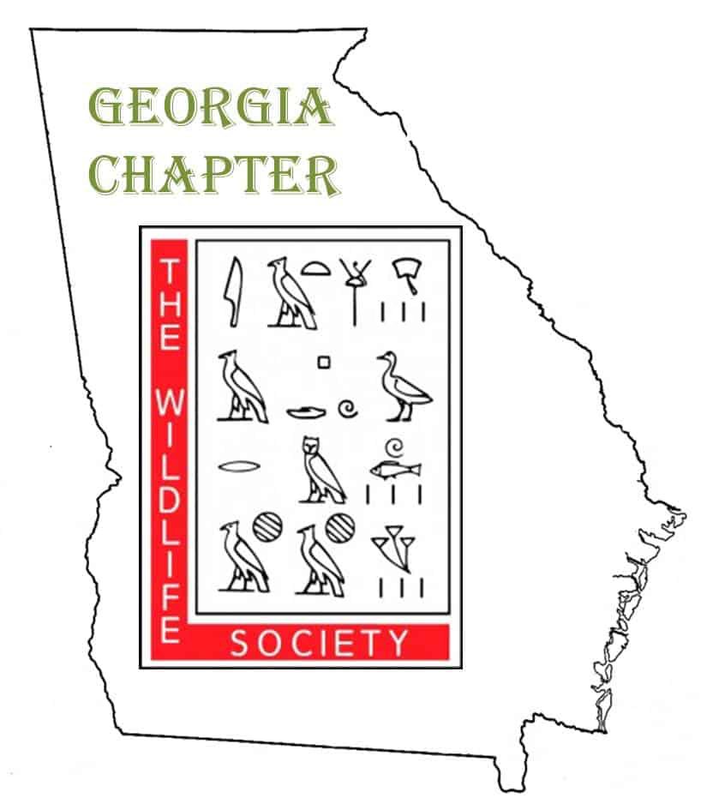

**2024 Annual Meeting**

**Dahlonega, GA**

**February 22-23, 2024**

Greetings GA TWS Members!

Registration for our upcoming Annual Meeting is now open! We are looking forward to seeing many of you! Details for registration, call for presentations, and awards are below.

**ANNUAL MEETING DETAILS**

**WHEN:** Thursday, February 22 & Friday, February 23, 2024

**LOCATION:** University of North Georgia Dahlonega Campus

Hoag Auditorium ([map here](https://ung.edu/campuses/_uploads/files/campus-bird-maps/dahlonega/ung-dahlonega-campus-buildings.pdf))

*Please see parking information in FAQ section of the eventbrite registration page*

**MEALS:** Lunch on Thursday is included in your registration fee as well as coffee and snacks at the breaks. The Thursday night social will be at Pine Valley Recreation Center ([map here](https://www.google.com/maps/place/Pine+Valley+Outdoor+Recreation+Facility/@34.5122419,-84.0593811,17z/data=!3m1!4b1!4m6!3m5!1s0x885f6509ea98774b:0xbe477d9a0c7579ac!8m2!3d34.5122375!4d-84.0568008!16s%2Fg%2F1tj3ltgr?entry=tts&shorturl=1)) in Dahlonega. A social ticket ($20) includes food and drink and can be purchased during registration for the meeting.

**LODGING:** There are a number of conveniently located hotels in Dahlonega. We have a hotel room block at the Holiday Inn Express in downtown Dahlonega. To reserve your room click on the link here: [Book your room!](https://www.ihg.com/holidayinnexpress/hotels/us/en/find-hotels/select-roomrate?fromRedirect=true&qSrt=sBR&qIta=99801505&icdv=99801505&qSlH=ATLDA&qCiD=21&qCiMy=012024&qCoD=23&qCoMy=012024&qGrpCd=WCF&setPMCookies=true&qSHBrC=EX&qDest=32%20East%20Main%20Street,%20Dahlonega,%20GA,%20US&srb_u=1)

**To book via phone:**

IHG Reservations

**(800) 465-4329**

Please reference the group's name (wildlife conference) and Holiday Inn Express Dahlonega when booking by phone.

**FIELD TRIP:** Friday will include three half-day FREE professional development workshop options: 1) A﻿ guided tour of the Smithgall Woods State Park conservation area and Hardman Farms with Sautee Nacoochee Indian Burial Mound (space is limited!) 2) A﻿n intro to R Studio workshop hosted by Dr. Michel Kohl (geared towards beginners/graduate students). 3) A tour of the Chattahoochee National Forest Fish Hatchery in Suches. Sign up for your preferred workshop on the registration eventbrite page.

**TO REGISTER:** Please register on eventbrite XXXX by February 2, 2024.

**CALL FOR PRESENTATIONS**

We're looking for presenters to give agency updates, research presentations, and poster presentations! If you would like to feature your work with a presentation or poster, please submit your abstracts by January 26, 2024. Please email Jessy Patterson at [jrpatterson@ung.edu](mailto:jrpatterson@ung.edu) with any questions.

[Submit Oral Presentation Abstracts here](https://docs.google.com/forms/d/1z4r42VQ8OB5gDK258JyT98ML_9t4bH1DNfb3pD_kv1Q/edit)

[Submit Poster Presentation Abstracts here](https://docs.google.com/forms/d/1vG1k-p67ZQFyIFuB_NYqmSI4MRRANQS-w24ATM6MIBM/edit)

**STUDENT TRAVEL AWARDS**

GA TWS will offer travel grants for students to participate in the Georgia Chapter of The Wildlife Society Annual Meeting. Applicants must be current Georgia Chapter members, and preference will be given to students who will be presenting at the meeting. To apply for this travel award, complete [this form](https://docs.google.com/forms/d/1mQ1rTeFDr5Fv1xexHdr15vyMeg09K9VnRcfTbDZRDkU/edit) by January 26, 2024.

**PROFESSIONAL AWARDS**

GA TWS periodically awards the *GA TWS Early Career Award in Honor of Dr. Bob Warren* and the *Jenkins-Crockford-Hayes Wildlife Conservation Award*. Please visit [this page](https://wildlife.org/georgia-chapter/awards/) for more information. Nominees must be current Georgia Chapter members to receive awards. The deadline to submit nomination packages to Krisha Whiting at [krishawhiting@gmail.com](mailto:krishawhiting@gmail.com) has been extended to January 26, 2024.

**Please join us in being sustainable ~ bring a reusable water bottle** 

**and/or coffee cup to the annual meeting!**