***2024 Summer Workshop***

Additional Information

**How to Get to Sax-Zim**

Directions: when using a mapping app make sure to type in *Sax-Zim Bog Welcome Center* or the physical address (*8793 Owl, Avenue, Meadowlands, MN*) to get to the Sax-Zim Bog Welcome Center . You will know you have arrived when you see this beautiful sign!

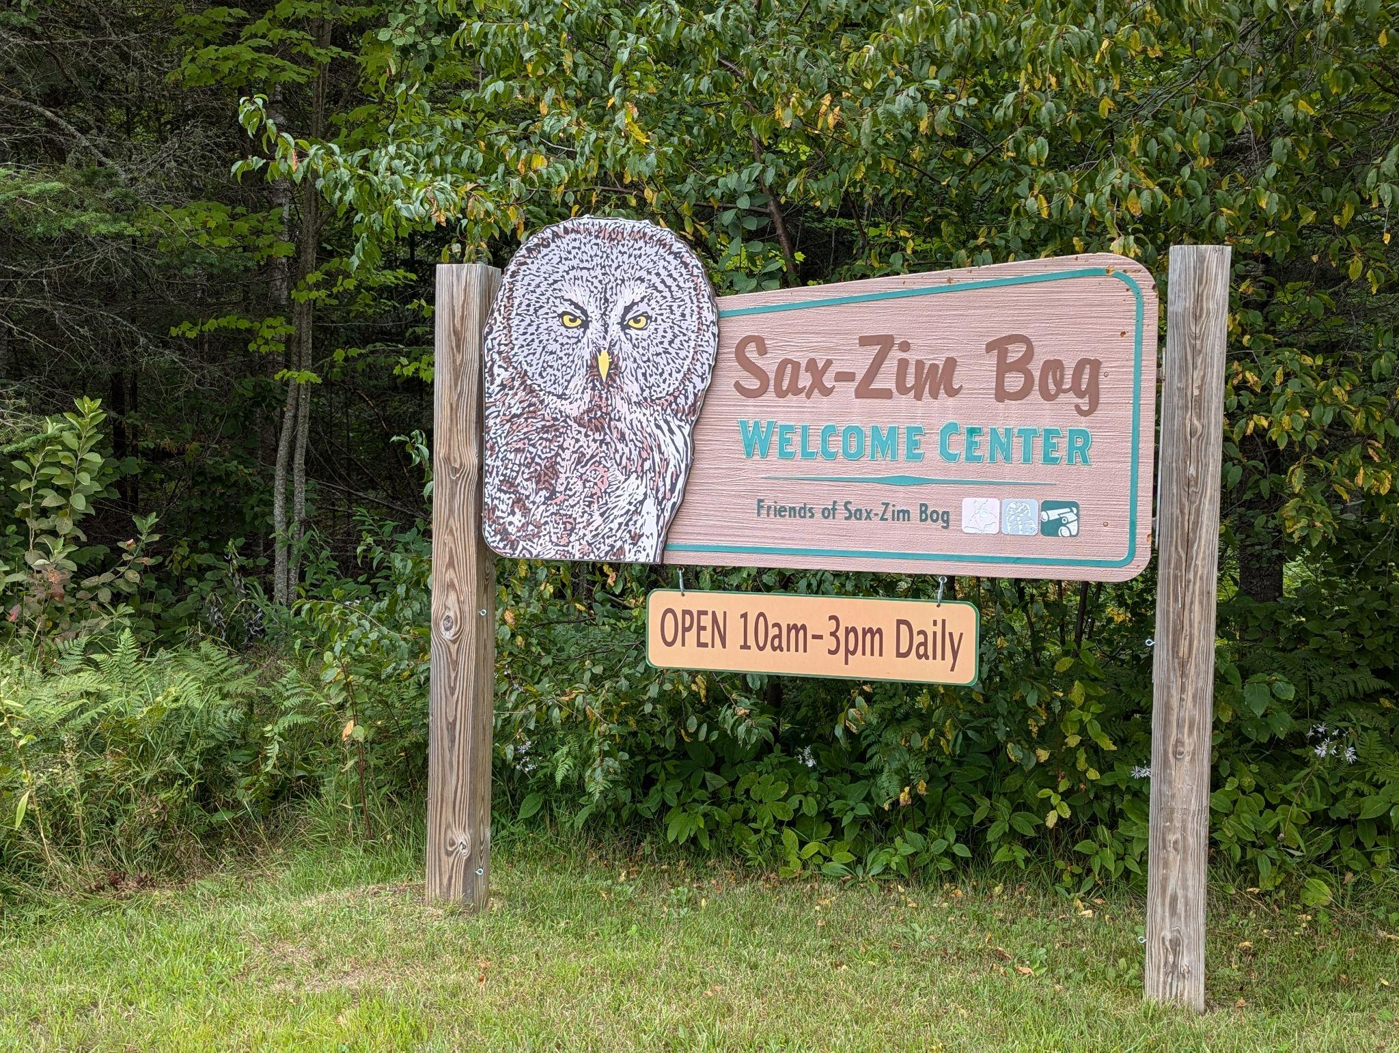

Parking: There is a 15 car parking lot. Please park on the left hand side, once that is full we may need to park along the roadway.

**What to Expect**

Cell phone reception may be spotty, depending on the carrier.

Amenities: there is no running water, however water and refreshments will be provided (see What to Bring). An outhouse is available (equipped with its own art gallery!)

Birding Map: This will be provided in the Welcome Packet (sent via email) and at the Visitor Center upon arrival. Includes trail locations, birding spots, restrooms, etc. Additional information on boardwalks and Trails can be found at the following link: [Boardwalks & Trails : Friends of Sax-Zim Bog (saxzim.org)](https://saxzim.org/boardwalks-trails/)

* Visit [Auggie’s Boardwalk](https://saxzim.org/boardwalks-trails/auggies-boardwalk/) and pick up a carved wooden owl as a souvenir
* Drive the [Winter Auto Tour](https://saxzim.org/birding-the-bog/winter-driving-tour/) route and keep your eyes open for birds.

Check out the Website [Friends of Sax-Zim Bog (saxzim.org)](https://saxzim.org/), Facebook Page [Friends of Sax-Zim Bog | Facebook](https://www.facebook.com/FOSZB/wall/) and blog posts [Bog Blog : Friends of Sax-Zim Bog (saxzim.org)](https://saxzim.org/sax-zim-bog-news/) for additional information on this amazing place!

One final consideration is that the Sax-Zim Bog is a remote landscape. Please plan accordingly and pack in what you pack out.

**Events**

**September 6, 2024**

Field Trip #1 - ***Tour of Sax-Zim Bog - FULL***

* Led by Clinton Dexter-Nienhaus, Head Naturalist, friends of Sax-Zim Bog
* The greater Sax-Zim Bog ecosystem offers a lot to visitors, no matter your interest in the natural world. With over 3600 species documented, the best way to experience the Bog is through the eyes of Friends of Sax-Zim Bog staff! Join us on a hike around the Welcome Center exploring all that northern Minnesota forests and bogs have to offer!
* **FULL:** Limit 10-15 people

Optional Field Trip - ***Self Guided Tour of Sax-Zim Bog***

* Take a self guided tour of Sax-Zim Bog before lunch. You will have an hour and a half to explore some of the additional trails and stops that Sax-Zim Bog has to offer (See Sax-Zim Bog Resources below).

Field Trip #2 - ***Tour of Sax-Zim Bog - Placeholder, if needed***

* Lead by Clinton Dexter-Nienhaus, Head Naturalist, friends of Sax-Zim Bog
* For those unable to attend the morning field trip, you are in luck! There will be a second Naturalist lead field trip!

Optional Field Trip - ***Self Guided Tour of Sax-Zim Bog***

* Take a self guided tour of Sax-Zim Bog in the afternoon. Explore some of the additional trails and stops that Sax-Zim Bog has to offer (See Sax-Zim Bog Resources below).

**September 7, 2024**

**Tiger Beetles Field Trip at Sax-Zim Bog**

*12:00-5:00 pm Meeting at the Lois King Education Center*

*Activity Rating: 2*

Tiger beetles are a colorful, yet overlooked group of beetles that are becoming quite popular to amateur entomologists and naturalists. Often, you find these species very commonly in gravel pits or open sandy areas. Their large eyes, bright colors, and tenacious attitudes are something to experience! Come out to learn a little more about these colorful and fast predators. This field trip will likely encounter all 8 species of tiger beetle in our region, with a chance to document the final species present in our region!

Register for this field trip here: [Tiger Beetles Field Trip](https://secure.lglforms.com/form_engine/s/ySlUN9383ANMxjWc9QvGAQ)

## Sunday, September 8

**Late Season Dragonfly and Damselfly Field Trip at Sax-Zim Bog**

*12:00-6:00 pm Meeting at the Lois King Education Center*

*Activity Rating: 2* Dragonflies and damselflies are an easily seen group of bugs and recently have become targets of cameras and nets! “Dragonflying” is becoming a popular hobby across the US and northern Minnesota has incredible odonate diversity. In the Sax-Zim Bog alone, we have documented 87 species of dragonfly and damselfly! This field trip will focus on seeing and catching adult dragonflies and damselflies. The late season offers diversity in darners, meadowhawks, and spreadwings, groups we don’t find during the early part of the summer. All ages and ability levels are welcome! Extra nets will be available for use to those who would like to use them.

Register for this field trip here: [Late Season Dragonfly and Damselfly Field Trip](https://secure.lglforms.com/form_engine/s/nDTxu0Fquvmf_1kOqTM7Jw)

**Where to Stay**

<https://saxzim.org/plan-your-visit/where-to-stay-when-visiting-the-sax-zim-bog/>

A block of hotel rooms has been reserved from September 5-6 at Super 8 in Eveleth, MN for $150/night. The block will be released to the public by August 6th, so book early!

Name: **MN Chapter Wildlife Society**

Group code: **090524MNC**

**Sax Zim Bog Resources**

[Friends of Sax-Zim Bog (saxzim.org)](https://saxzim.org/)

[Birding Map 2024 Sax-Zim Bog : Friends of Sax-Zim Bog (saxzim.org)](https://saxzim.org/birding-the-bog/birding-map-2018-19/)

[Sax-Zim Birding List (saxzim.org)](https://saxzim.org/wp-content/uploads/2023/05/Sax-Zim-Bog-Bird-Checklist-2015-55561-bird-checklist.pdf)

[Boardwalks & Trails : Friends of Sax-Zim Bog (saxzim.org)](https://saxzim.org/boardwalks-trails/)

**What to Bring**

[Plan your Visit : Friends of Sax-Zim Bog (saxzim.org)](https://saxzim.org/plan-your-visit/#preparingvisit)

* Reusable bottle (there is no running water, though water will be provided)
* Reusable utensils, plates, and cups (compostable plates, cups, utensils will be provided)
* Head net
* Binoculars and hand lenses to view wildlife, lichens, etc.
* Daypack
* Rain gear
* Bug spray and sunscreen