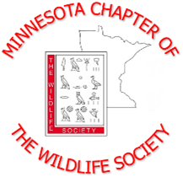
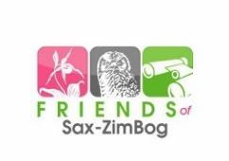
2024 Summer Workshop

Wetlands That Can’t Be Peat:
Exploring the Relationship Between Bogs and Wildlife

Friday, September 6, 2024
Sax-Zim Bog | Lois King Education Center | 8793 Owl Avenue Toivola, MN

Registration - Register early! Space is limited, approximately 30 spots available! Due by August 9, 2024.
Name: _______________________________ Pronouns: ____________________ Organization: ________________________________________________________ Phone: _______________________ E-Mail:________________________________
Type (select one; includes main workshop with lunch and breaks, and optional field trip(s))
_____ Professional Registration – $30
_____ Student Registration – $15

Optional Field Trips - Please select which field trip(s) you would like to attend. See “Additional Information” and “Draft Agenda” for more details (final agenda is subject to change and will be based on interest/attendance of field trips).
_____ Naturalist guided tour at Sax-Zim Bog before lunch - Full
_____ Naturalist guided tour at Sax-Zim Bog after lunch
_____ Self guided tour of Sax-Zim Bog (opportunities in morning and afternoon)

Payment Method (select one)
______ Credit Card: Scan and email your registration form to reid.plumb87@gmail.com. Reid Plumb will send you a PayPal invoice at the email you provide. Payment can then be made with a credit card online via PayPal.
______ Check or Cash: Mail your payment (make checks out to MN TWS) with your registration form to: Reid Plumb, 24634 County 9, Bemidji, MN 56601.
______ Groups: If you plan to register as a group or if multiple people from the same organization are attending, please contact melissa.l.gabrielson@usda.gov and reid.plumb87@gmail.com for more information.
Please see the “Additional Information” and “Draft Agenda” for specifics on optional field trips, lodging, and more. Final Agenda is subject to change based on interest in optional field trips.

