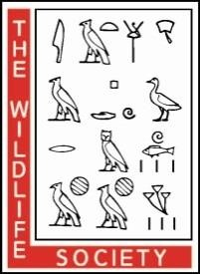
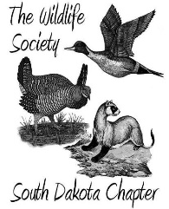
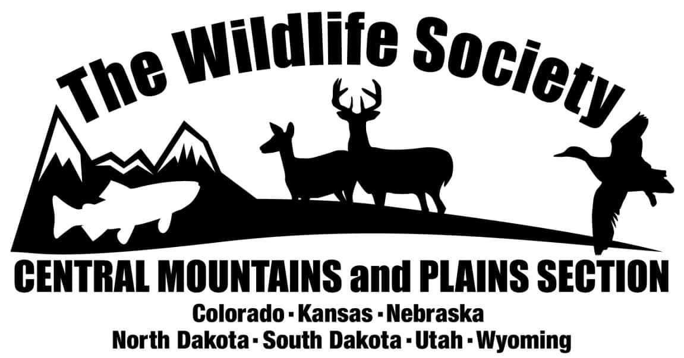

2024 SDTWS and CMPS Combined Annual Meeting Ramkota Hotel & Conference Center at Rapid City, South Dakota

March 20-22, 2024

WEDNESDAY, 20 March

11:00 – 1:00 Registration and Lunch (Free lunch with registration)

1:00 – 1:15 Welcome and Introductions

Special Session: Conservation across scales

1:15 – 1:45 Resource selection and survival of Plains Sharp-tailed Grouse at a wind energy facility – Carly Kelly, West Ecosystem Technology, Inc *VIRTUAL

1:45 – 2:15 Conservation in the Prairie Pothole Region – A Working Land’s Approach – Bruce Toay – South Dakota Ducks Unlimited

2:15 – 2:45 Applying Successes of Waterfowl Model to Conservation of Grassland Birds – Neal Niemuth – USFWS HAPET program *VIRTUAL

2:45 – 3:00 Break

3:00 – 3:30 Bumble Bee Atlas Projects: Collaboratively tracking and conserving bumble bees in order to conserve them – Rich Hatfield – Xerces Society

3:30 – 4:00 Audubon Conservation Ranching Initiative – Josh Lefers – Audubon

4:00 – 4:30 The Central Grasslands Roadmap: what it is and why we need your
involvement – Maggie Hanna – Central Grasslands Roadmap

5:00 – 6:00 Social
6:00 – 7:00 Supper (Free with registration)
7:00 – 8:00 Quiz Bowl

THURSDAY, 21 March

8:00 – 9:00 Committee Meetings
8:00 – 9:00 TWS Certification Workshop
9:00 – 12:00 Annual Chapter Business Meeting (Rolls and coffee provided)

12:00 – 1:00 Luncheon – CMPS Annual Business Meeting

1:15 – 1:35 Why TWS – Bob Lanka, President TWS

1:35 – 1:55 Tier II duck hunting regulations in Nebraska and South Dakota – Rocco Murano – SDGFP *VIRTUAL

1:55 – 2:15 State of the Bison Union; A look into the future of the bison program at South Dakota State – Philip M. Urso – SDSU

2:15 – 2:35 North American Wetlands Conservation Act Update – Rick Warhurst

2:35 – 2:55 Quantifying bison landscape utilization and distribution at multiple scales using cost effective GPS tracking collars in the Sandhills Mixed – Grass Prairie – Ira L. Parsons – SDSU

2:55 – 3:10 Break

3:10 – 3:30 When friends become enemies: Rethinking our relationship with our most treasured shrubberies – Cody Grewing – Audubon

3:30 – 4:00 Conserving Biological Diversity – Should Hunters Do More? – Bob Lanka, President TWS

4:00 – 5:00 WOW – Women of Wildlife event w/ Andrea Orabona presentation

5:00 – 6:00 Social
6:00 – 7:00 SDTWS and CMPS Award Ceremony and Supper
7:00 – 8:00 KEYNOTE: Larkin Powell - The Best of Intentions: private lands, wildlife, and the future of conservation in the Great Plains
8:00 – 8:30 Silent Auction winners announced (Social continued)

FRIDAY, 22 March

9:00 – 9:20 Raptor Translocation in North and South Dakota – Tara Darby USDA

9:20 – 9:40 Vegetation and Avifauna Interactions in eastern South Dakota wetlands enrolled in the USDA-NRCS Agricultural Conservation Easement Program (ACEP) – Kat Millman MS – SDSU

9:40 – 10:00 Habitat associations and distribution modeling of the plains spotted skunk (Spilogale interrupta) in South Dakota – Kara White PhD – SDSU

10:00 – 10:20 Break

10:20 – 10:40 Factors Influencing Population Growth in a Bobcat Population
– Chadwick Lehman – SDGFP

10:40 – 11:10 Characterizing a Free-Roaming Cat Population to Predict Predation of Threatened Island Species – Sarah Gheida MS – SDSU

11:10 – 11:30 Thermoregulation and Body Size Across the Upper Midwest – Hayden Wolfe MS – SDSU

11:30 – 11:45 Present Student and Open Presentation Awards

THE WILDLIFE SOCIETY
Founded in 1937 as The Society of Wildlife Specialists, The Wildlife Society has evolved into an international nonprofit organization of professional wildlife ecologists and managers. Members number over 10,000 from 40 different countries, and include administrators, biologists, conservation officers, educators, managers and researchers.
The objectives of TWS are to:
- Promote sound stewardship of wildlife resources and the environments
upon which wildlife and humans depend;
- Undertake an active role in preventing human-induced environmental degradation;
- Increase awareness and appreciation of wildlife values; and
- To seek the highest standards in all activities of the wildlife profession.
SOUTH DAKOTA CHAPTER OF THE WILDLIFE SOCIETY
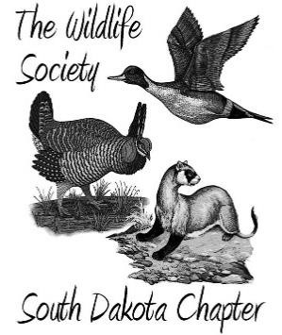
The South Dakota Chapter of TWS (SDTWS) was initiated on February
19, 1966 with 56 charter members. SDTWS is affiliated with the Central Mountains and Plains Section, one of eight subdivisions of TWS. The full membership of SDTWS meets annually in the spring to exchange scientific information through presented papers, debate current issues in wildlife management and land use, and conduct chapter business. The chapter’s Executive Board of Directors, consisting of President, Past President, President-Elect, Secretary-Treasurer, and two standing board members meet at least 4 times each year to discuss issues that don not require full chapter approval. The chapter also communicates with its members through a newsletter, The Prairie Voice, published within 30 days of Executive Board meetings. SDTWS has a current membership of 171 people interested in the welfare of South Dakota wildlife.

2024 Meeting Sponsors
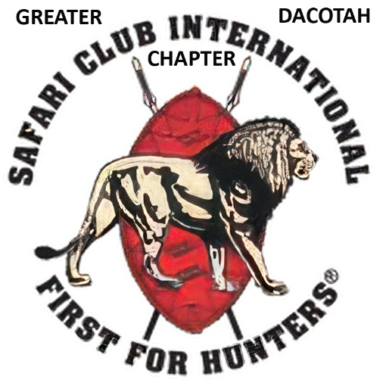
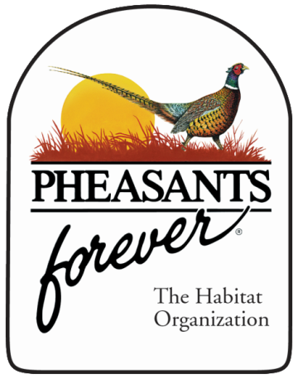
We Greatly Appreciate Your Continued Support!!!
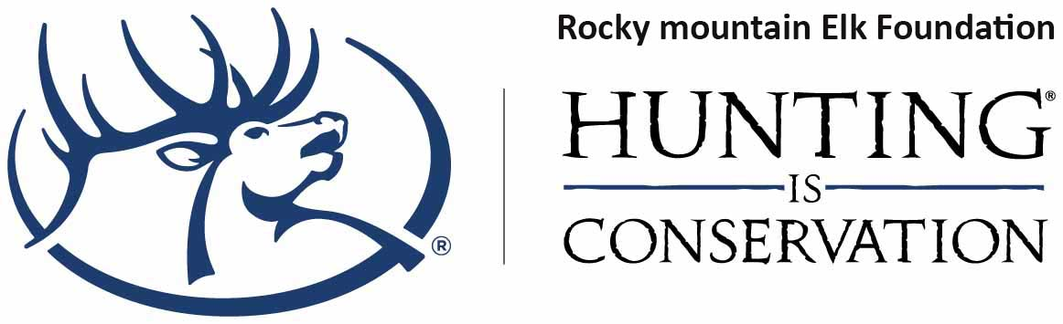
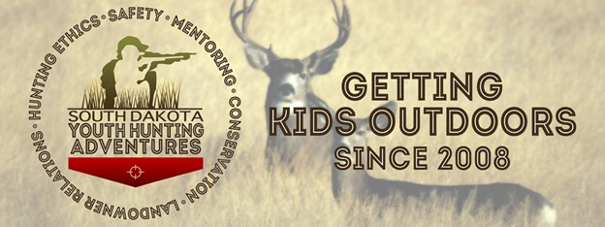
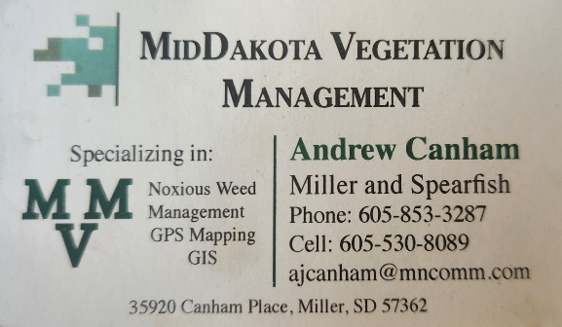
RESOURCE SELECTION AND SURVIVAL OF PLAINS SHARP-TAILED GROUSE AT A WIND ENERGY FACILITY

Carly S. Kelly Western Ecosystems Technology, Inc., 1610 Reynolds Street,
Laramie,WY 82072, USA and Department of Ecosystem Science and Management, 1000 East University Avenue, University of Wyoming, Laramie, WY 82071, USA
Chad W. LeBeau Western Ecosystems Technology, Inc., 1610 Reynolds Street, Laramie,
WY 82072, USA
Jeffrey L. Beck Department of Ecosystem Science and Management, 1000 East
University Avenue, University of Wyoming, Laramie, WY 82071, USA
Alex Solem South Dakota Department of Game, Fish, and Parks, 895 3rd Street
SW,Huron, SD 57350, USA
Hilary Morey South Dakota Department of Game, Fish, and Parks, 895 3rd Street
SW,Huron, SD 57350, USA
Kurt T. Smith Western Ecosystems Technology, Inc., 1610 Reynolds Street,
Laramie,WY 82072, USA

³South Dakota Department of Game, Fish, and Parks, 895 3rd Street SW, Huron, SD 57350, USA

Abstract. As the demand for wind energy development increases across much of the Great Plains region, there is a need to understand how this type of energy generation may impact wildlife. Due to their extensive range across areas with high quality wind resources and their economic importance, plains sharp-tailed grouse (Tympanuchus phasianellus jamesi) represent a valuable species to evaluate responses associated with wind energy development. We used spatial and demographic data collected from 130 radio-marked female sharp-tailed grouse to evaluate the effects of a wind energy development on resource selection (nest, brood-rearing, and breeding season) and survival (nest and female) during the April to August breeding season over a 3-year period from 2020–2022 in north-eastern South Dakota, USA. We did not find evidence that females selected nest sites in relation to wind energy infrastructure but found that females with broods and during the breeding season avoided areas near high densities of wind turbines within their home ranges. We found consistent selection for lower lengths of transmission lines across all life stages at the home range scale. We did not detect an effect of wind energy infrastructure on nest or female survival; however, we caution the effect on female survival may be biologically meaningful. Our results have implications for siting future wind energy development in ways that can minimize impacts to breeding sharp-tailed grouse.

CONSERVATION IN THE PRAIRIE POTHOLE REGION – A WORKING-LAND’S APPROACH
Bruce Toay, Manager of Conservation Programs, Ducks Unlimited, Inc.,
Ipswich, SD.
Abstract. The Prairie Pothole Region spans over 700,000 km2 across two countries. The glaciated plains and seasonal climate provide the combination of wetlands and grasslands necessary to produce over 2/3 of the continent’s waterfowl population. This region remains Ducks Unlimited’s highest priority landscape due to the importance to breeding waterfowl, the most critical time in the waterfowl life cycle. This region remains at a high risk of conversion. Already, over half of the wetlands and grasslands in the Prairie Pothole Region have been lost for agricultural intensification or urbanization and in some geographies those loss rates are closer to 90%. We know that retention of existing intact habitats is the most cost-effective strategy for habitat conservation. How do we prioritize the retention of grassland and wetland habitats in a landscape dominated by private ownership and agricultural land use? In order to achieve landscape-scale conservation in the Prairie Pothole Region, we must be providing services and selling programs that are attractive to ranchers and farmers utilize these same habitats. Focusing on the shared objectives of diverse and sustainable agriculture, and soil health, Ducks Unlimited has developed a successful model for working land’s conservation in the Prairie Pothole Region.
Bruce has BS Degree in Fisheries and Wildlife Biology from the University of North Dakota. He worked 6 seasons with the USFWS in North Dakota at Arrowwood National Wildlife Refuge and Kulm Wetland Management District. He was worked for Ducks Unlimited in South Dakota since 2006, as a Biologist, Regional Biologist, and now as the Manager of Conservation Programs.
Applying the Waterfowl Conservation Model to Grassland Birds

Neal D. Niemuth, USFWS Habitat and Population Evaluation Team, Bismarck ND
Kevin W. Barnes, USFWS Habitat and Population Evaluation Team, Hadley MA
Heath M. Hagy, USFWS Habitat and Population Evaluation Team, Bismarck ND
Michael E. Estey, USFWS Habitat and Population Evaluation Team, Fergus Falls MN

Abstract Population trends for North American bird groups 1970-2017 are bookended by grassland birds, which showed the greatest loss of individuals from ten breeding biome groups, and waterfowl/wetland birds, which were the only breeding biome group to show a population increase during the analysis period. Positive trends for waterfowl populations were attributed to management actions, leading multiple scientists and conservation leaders to advocate waterfowl management as a model for conservation of other species, particularly grassland birds. Species richness and abundance of both waterfowl and grassland birds are highest in the northern Great Plains, affording a unique opportunity to assess relative population responses to conservation efforts in the region. We found that largest increases in continental populations of breeding ducks occurred in the U.S. Prairie Pothole Region with high levels of waterfowl conservation efforts and that waterfowl conservation has benefitted millions of individuals of grassland birds. In fact, abundance of several grassland bird species that use moist soils and wetland margins has increased in portions of the PPJV with high levels of waterfowl conservation, counter to patterns across most of North America. Our findings suggest that conservation of grassland birds across the continent would benefit from the same efforts that have benefitted waterfowl populations: high levels of focused, long-term conservation delivery that are guided by use of spatial models and decision-support tools that consider biological value, cost, and risk of habitat loss. Current monitoring, planning, and modeling efforts are sufficient to support increased conservation delivery, provided that dedicated funding is available for non-waterfowl grassland birds.

Bumble Bee Atlas Projects: Collaboratively tracking and conserving bumble bees in order to conserve them.

Rich Hatfield Senior Conservation Biologist Endangered Species Program, Xerces
Society, Portland, OR

Abstract:
Bumble bees are essential pollinators in both agricultural and natural settings. Unfortunately, due to myriad threats like pesticides, climate change, disease and habitat loss, many species of bumble bees face an uncertain future. A barrier to enacting evidence-based conservation action to adequately protect bumble bees is a lack of data. Missing is detailed information about bumble bee populations at a scale sufficient to fully understand their conservation status, and the species-specific spatial and habitat information needed to direct focused efforts toward the species that need conservation attention most. To address this information gap, the Xerces Society and partners have launched regional Bumble Bee Atlas projects across much of the United States. These projects, which will be active in 20 states (including ND, SD, NE, KS, CO, WY, and UT), and more than 1/2 of the land area of the Continental United States in 2024, have engaged thousands of volunteers across the country and gathered over 50,000 observations of bumble bees from thousands of effort-based surveys. Ultimately, this effort is providing essential data to federal and state agencies mandated with regulatory decisions, and practical information to the land management agencies tasked with conserving bumble bees. This talk will broadly address the approach of the Atlas program, our findings to date, and future directions for 2024 and beyond.

Conservation Ranching Program

Josh Lefers. Audubon

Grassland birds have suffered an unparalleled decline over the past half century, stemming from widespread development of North America’s grasslands. To combat the negative effects of grassland degradations—and to keep grass on the landscape—Audubon has developed the Conservation Ranching Initiative. This market-based conservation approach offers incentives for grassland stewardship through a certification label on beef products. For the first time, consumers can contribute to grassland conservation efforts by selectively purchasing beef from Audubon-certified farms and ranches. The Audubon certification seal brings a broad market appeal that enhances demand by consumers that want options for beef that is sustainably raised and benefits wildlife habitat.

The Central Grasslands Roadmap: what it is and why we need your involvement

Maggie Hanna- Director, Central Grassland Roadmap Initiative

The Central Grasslands Roadmap represents a diverse coalition striving to elevate and promote grassland conservation for future generations across 3 countries, Sovereign Indigenous Nations and 7 sectors. Beyond countries and Nations, the 7 sectors include; private land owners/producers, provincial and state agencies, industry, academia, non-governmental organizations, foundations, and federal governments. Spanning USA, Canada, and Mexico, this region represents 700 million acres, 60% of which has been converted to row-crop agriculture or has extensive invasion of woody trees and shrub species. Of the remaining 40% still in grass, half is vulnerable to conversion or degraded from woody species encroachment. Over the past four years, more than 750 people and 250 partners have contributed their perspectives on policy and funding needs, partnerships, communication, and science to address these biome challenges. The Central Grassland Roadmap operates under a constellation governance model to promote equity and inclusive engagement. Learn more at www.grasslandsroadmap.org.

Together we want to conserve and enhance existing intact grasslands while strategically addressing threats that ultimately result in a net gain in healthy grasslands and more sustainable croplands. Our 10-year landscape goal is to restore and enhance 100 million acres. These actions will improve overall grassland condition, stabilize or reverse declining wildlife populations, improve water quality and quantity, enhance soil health, address economic challenges of the region, and help support diverse communities and cultures that have shaped our region for hundreds to thousands of years. The future of our grasslands depends upon elevating grasslands as a priority for investment, restoring ecological processes, reversing declines of threatened species and promoting healthy human communities.
Talk Abstracts

Factors Influencing Population Growth in a Bobcat Population

CHADWICK P. LEHMAN*, South Dakota Game, Fish, and Parks, Custer, South Dakota 57730 USA
ERIN E. MORRISON, Division of Forestry and Natural Resources, West Virginia University, Morgantown, West Virginia USA
BRADY Y. NEILES, South Dakota Game, Fish, and Parks, Custer, South Dakota 57730 USA
Christopher T. Rota, Division of Forestry and Natural Resources, West Virginia University, Morgantown, West Virginia USA

ABSTRACT Bobcats (Lynx rufus) are the most broadly distributed native felid in North America and have substantial ecological and economic importance. Despite this importance, little is known about factors influencing population dynamics of this cryptic carnivore. Given recent apparent declines in abundance, we investigated population growth rate (λ) for a bobcat population in the Black Hills, South Dakota, USA, 2016–22. We constructed and evaluated a females-only matrix population model. Our estimate of asymptotic λ, derived from estimates of vital rates obtained over a 6-year period, was 0.85 (95% CI = 0.72, 1.02), which indicates that the vital rates in 2016–22 were inadequate to sustain the population. Elasticity and sensitivity values were highest for changes in adult survival probability followed by, in order, changes in kitten/juvenile survival, and adult reproductive contribution. Life stage simulation analysis also supported that adult survival was most important; however, the juvenile survival (91 day–1 year) component of a bobcat’s first year of life was also important and a stronger driver of population growth than the kitten survival (first 90 days) component. For the combination of survival and reproductive rates found in our study, positive population growth required either annual adult survival >0.85 or 275-day juvenile survival >0.35, regardless of other vital rates. When assuming a baseline harvest rate of 23.5%, we found that reducing the harvest rate to 9% led to a positive mean growth rate and a >0.50 probability of a growing population. Monitoring juvenile-to-adult harvest ratios can provide an indicator of age structure in the population, and we recommend restricting harvest when that ratio falls below 10%, particularly when managers lack research information on population growth.

*Presenting Author

Tier II duck hunting regulations in Nebraska and South Dakota

Rocco Murano, South Dakota Game, Fish and Parks, 2810 22nd Ave, Brookings, SD
57006
John McKinney, Nebraska Game and Parks Commission, 2200 N 33rd St, Lincoln, NE
68503 john.mckinney@nebraska.gov
Mark Vrtiska, University of Nebraska – Lincoln, 3310 Holdrege Street, Lincoln, NE
68583
Matthew P. Gruntorad, University of Nebraska – Lincoln, 3310 Holdrege Street,
Lincoln, NE 68583
Christopher J. Chizinski, University of Nebraska – Lincoln, 3310 Holdrege Street,
Lincoln, NE 68583

Relative to other forms of hunting, duck harvest is managed by regulations that are species- and sex-specific that require hunters to identify ducks in flight. These regulations are often cited as inhibiting, or in some instances prohibiting, new hunters to try duck hunting. The two-tier duck hunting regulation experiment went into effect during the 2021-2022 hunting season in Nebraska and South Dakota, where hunters could choose between a simplified three-bird daily bag limit with no species or sex restrictions (Tier-II), or the traditional six-bird daily bag limit with species and sex restrictions (Tier-I). We conducted a survey of Tier-II hunters following each hunting season. Hunters most frequently reported they had hunted ducks in previous years, but the majority of hunters claimed that they had chosen Tier-II because they were not confident with their duck identification skills. Those who had never hunted ducks before were more likely to agree that using Tier-II helped them develop their duck identification skills ($χ^{2}$ = 58.37; P < 0.01; OR = 3.97). Qualitative coding of hunter interviews identified six major themes for Tier II participation including “helped me learn,” “want more opportunity,” “three is enough,” “disinterested in identification,” “species specific,” and “generally displeased”. The state of future waterfowl-hunter participation is a serious concern of wildlife agencies across the United States. Our results suggest that a significant proportion of new waterfowl hunters make use of the three-duck bag limit, and the two-tier system may relieve hunting-constrains in a meaningful way. Wildlife agencies may want to consider the effects of the two-tier system on hunter participation in the future as well as track how hunters transition between bag-limit regulations from year-to-year.

State of The Bison Union; A look into the future of the bison program at South Dakota State.

Philip M. Urso, Department of Animal Science, South Dakota State University,
Department of Animal Science, South Brookings, South Dakota 57006

Bison are not new to North America. However, they are relatively new in the field of intensive animal management. South Dakota State University has made considerable efforts to further the field of bison production through research and extension outreach. They have now made efforts to grow the field of bison education as well. Philip Urso is the newest assistant professor at SDSU and is focusing on Bison Studies. In this seminar, Dr. Urso will detail where the bison industry stands according to researchers, academics, and stakeholders. These topics include the research that has been conducted, areas of concern, and how to address current issues such as proper nutrition, management practices, and tribal access. He will also be disclosing the plans for a bison centered teaching agenda in at South Dakota State headquartered in Brookings, South Dakota in the Department of Animal Science.

North American Wetlands Conservation Act Update

Rick Warhust

The North American Wetlands Conservation Act of 1989 (NAWCA) was passed by the United States Congress in part to support North American Waterfowl Management Plan activities. The scope of NAWCA greatly expanded with development of the Partners in Flight Bird Conservation Plan, U.S. Shorebird Conservation Plan and North American Waterbird Conservation Plan. NAWCA provides funding for wetland projects in the U.S., Canada, and Mexico. A minimum of a 1:1 match is required. A scoring process that includes seven Technical Assessment Questions is used by NAWCA Staff to help evaluate each project. NAWCA Staff reads and scores projects and develops a recommended slate of projects for each round of proposals. The slate of projects is submitted to the NAWCA Council. The NAWCA Council reviews and discusses the slate of projects and approves a recommended slate of projects which are submitted to the Migratory Bird Conservation Commission for approval and funding. The NAWCA Process will be reviewed. NAWCA Council membership and members and NAWCA Staff will be explained.

Quantifying landscape utilization and distribution at multiple scales using cost effective GPS tracking collars in the Sandhills Mixed-Grass Prairie
Ira L. Parsons, PhD, Department of Animal Science, South Dakota State University
West River Research and Extension, Rapid City, SD 57703
Jameson R. Brennan, PhD, Department of Animal Science, South Dakota State
University West River Research and Extension, Rapid City, SD 57703

Remote GPS tracking technology presents the tremendous potential to study bison behavior, distribution, and use patterns in extensive and complex landscapes. Commercially available wildlife tracking devices are expensive and cost prohibitive, while frequently collecting fix intervals ranging from one to several hours (Sheppard et al., 2021) for both researchers and managers. The objective of this study was to study daily and seasonal individual movement and topographic land use a various temporal scales in pastures of varying size and functional scale. Forty-one Bison (bison bison bison) bulls and cows were collared on the McGinley ranch located in the Nebraska Sandhills using GPS receivers programed for 5-minute fix intervals (Brennan et al., 2021) and mounted a modified stock collar in February 2022 and retrieved in February, 2023. Geospatial data processing was conducted in Program R using the sf and terra libraries (R Core Team, 2023). A 10-meter DEM layer was downloaded from the GIS web database and used to calculate topographical indices, including the Topographical Water Index, Topographical class, and slope. Utilization distribution was calculated by overlaying a 25-meter grid across the landscape, extracting calculated landscape values to each grid cell, and counting the total number of standardized fix interval GPS locations existing within each cell for each animal (Raynor et al., 2021). A zero inflated GLM model was fitted to the data using the MASS package to identify predictors of landscape use. Slope was the strongest predictor of bison space use, with all animals preferring lowlands and flat terrain over slopes (p < 0.01), with various preferences between individuals. These results indicate the power of cost-effective tracking collars, and demonstrate opportunities to identify essential utilization corridors and more effectively distribute space utilization in bison managed on extensive prairies.

Student Talks

Vegetation and Avifauna Interactions in eastern South Dakota wetlands enrolled in the USDA-NRCS Agricultural Conservation Easement Program (ACEP)

Katherine Millman South Dakota State University, Department of Natural Resource
Management, Brookings, South Dakota 57006
Joshua D. Stafford U.S. Geological Survey, South Dakota Cooperative Fish &
Wildlife Research Unit, Brookings, South Dakota 57006
Mercedes Batalla South Dakota State University, Department of Natural Resource
Management, Brookings, South Dakota 57006
Steve R. Chipps U.S. Geological Survey, South Dakota Cooperative Fish & Wildlife
Research Unit, Brookings, South Dakota 57006

Abstract: The USDA-NRCS Agricultural Conservation Easement Program (ACEP) works with private landowners to conserve and restore wetlands to provide ecosystem services, including wildlife habitat. We selected 25 wetlands in Southeastern South Dakota to survey and quantify avian and vegetation characteristics during Summer 2023. Of these sites, 15 were enrolled in ACEP, and the remainder were federal and state properties that served as minimally-disturbed control sites (n = 5), and sites heavily influenced by nearby agriculture (n = 5). At each site we sampled herbaceous vegetation, trees, and avifauna. Vegetation was sampled by measuring species richness and cover in 15 quadrats (1 m²) sampled across three vegetation zones (wet meadow, marsh, and open water). We recorded the number, species, and diameter at breast height (DBH) of all tree species within 100 m of wetland bank full boundaries. We used point counts to quantify avian abundance and diversity at the beginning (mid-July) and end (late August) of the field season. Point counts included 3 10-minute surveys at each wetland, with points spaced ≥200 m apart. Vegetation diversity was generally low, with invasive and aggressive species (e.g., Typha spp., Phragmites australis, Phalaris arundinaceae, Cirsium arvense, Sonchus arvensis, Bromus inermis, and Teucrium canadense) as the most commonly recorded across all sites. Avifauna varied greatly by survey date and among sites, with abundances ranging from single individuals of few species to hundreds of individuals of many species. Variation in avian abundance and diversity was likely related to the time of year of the survey, water depth, tree presence, and other biotic and abiotic factors. By monitoring the linkage of vegetation and avian diversity, this research will allow conservation partners to better monitor and restore wetlands to maximize vegetation quality and bird habitat in the future.

Habitat associations and distribution modeling of the plains spotted skunk (Spilogale interrupta) in South Dakota

Kara M. White South Dakota State University, Department of Natural Resource
Management, 1390 College Avenue, Brookings, SD 57007, USA
Amanda Cheeseman South Dakota State University, Department of Natural Resource
Management, 1390 College Avenue, Brookings, SD 57007, USA
Joshua Stafford U.S. Geological Survey, South Dakota Cooperative Fish and Wildlife
Research Unit, South Dakota State University, 1390 College Avenue, Brookings, SD 57007, USA
Robert C. Lonsinger U.S. Geological Survey, Oklahoma Cooperative Fish and Wildlife
Research Unit, Oklahoma State University, 007 Agriculture Hall, Stillwater, OK 74078, USA

Abstract: The plains spotted skunk (Spilogale interrupta) is a data-deficient small carnivore native to the central plains of North America that has experienced significant population declines. Our study investigates the species’ distribution and habitat associations in South Dakota, which is crucial for informed conservation actions. We first developed ensemble distribution models at a broad scale, incorporating species location data from 1985–2020, environmental factors, and six predictive modeling algorithms. We identified key predictors including mean temperature diurnal range and proportion of area as pasture, and estimated ~31,300 km² of potential habitat, predominately in eastern South Dakota. We also tracked 14 plains spotted skunks in spring and summer of 2021 and 2022. We analyzed resource selection at the point scale with 300 m² buffers for landcover variables. Our mixed-effects logistic regression analysis indicated that plains spotted skunks selected for areas near permanent small-scale farming structures (i.e., rock piles, fences, and farm buildings) and avoided crop cover, with varying responses to human development, wetland density, and hay bales across seasons. Our results highlight the plain spotted skunk’s adaptability to different land uses, emphasizing the importance of low-intensity agricultural practices in determining habitat suitability. By integrating fine-scale habitat analysis with broad-scale distribution modeling, using a mix of historical (1985–2020) and contemporary (2021–2022) data, our research provides important insights for conservation strategies that aim to protect and recover plains spotted skunk populations in the northern Great Plains.

Characterizing a Free-Roaming Cat Population to Predict Predation of Threatened Island Species

Sarah Gheida, South Dakota State University, M.S. Graduate Research Assistant

Rachel Short PhD, South Dakota State University, Assistant Professor

Kaua'i is the northernmost of the major Hawaiian Islands and the breeding ground for a significant portion of the endangered 'ua'u (Hawaiian Petrel, Pterodroma sandwichensis) and 90% of the threatened 'a'o (Newell’s Shearwater, Puffinus newelli) populations, making this island critical to the survival of these species. However, these seabirds have experienced sharp declines on Kaua'i in recent decades, with 78% and 94% of populations lost, respectively. Like many island species that evolved without mammalian predators, the seabirds are especially vulnerable to free-roaming domestic cats (Felis catus) introduced globally by humans. Cats are successful predators responsible for 35.6% of seabird predations on Kaua'i and have a significant impact through predation of breeding adult birds. Yet, there are few studies examining demographics, morphology, and diet of feral cats, and no studies on Kaua'i. In collaboration with Hallux Ecosystem Restoration, LLC (HER), the wildlife management organization that maintains the largest collection of cat skulls (n ≈ 400) and associated data (age, sex, and diet) of free-roaming cats on the island, we aim to highlight demographic and morphometric characteristics of cats known to predate seabird. We detailed the population-level age, sex, and body size of cats in three regions of Kaua'i. Then, we used cranial measurements to calculate bite force for a subsample of skulls and compared these metrics with demographic information from the island-wide population. Preliminary results indicate adult and male cats display a higher bite force. Future work will calculate bite force for the remainder of the sample and use dietary data to identify those cats that predate seabird. By integrating the combined demographic, morphometric, and dietary data, we will highlight characteristics of cats responsible for seabird predation on Kaua'i. These findings can then be used by HER staff and biologists globally for targeted management of free-roaming cats that threaten native species.

Bison Thermoregulation and Body Size Across the Upper Midwest
Hayden Wolfe^{1,2},

Bradly Wehus-Tow, Department of Natural Resource Management, South Dakota
State University, Brookings, SD, USA and Center of Excellence for Bison Studies, South Dakota State University, Rapid City, SD, USA
Jameson Brennan, Department of Animal Science, South Dakota State University,
Brookings, SD, USA
Danielle Buttke, Office of Public Health and Wildlife Health Branch, National Park
Service, Fort Collins, CO, USA
Jeff M. Martin, Department of Natural Resource Management, South Dakota State University, Brookings, SD, USA

Presenting author name and career stage: Hayden Wolfe, I am pursuing a M.S. degree

Every year, one-eighth of all bison (Bison bison) are translocated across North America, often across large climatic gradients (mean annuals of: temperature (MAT), precipitation (MAP), Palmer drought severity index (PDSI), and aridity index (AI)). We evaluated the influence of those gradients on herd-level thermoregulation (i.e., heat flux) and asymptotic body mass (ABM). Over the last 20 years bison have been translocated from Wind Cave National Park to establish 6 closed-herds across the Upper Midwest (IA, MO, IL, IN, and KS). Across 3 years, we sampled 1174 bison from those 7 sites, taking thermal images to estimate heat flux (an estimate of thermoregulatory effort) and using photogrammetry to estimate ABM. Using a mixed-effects model we found that heat flux rate (Watts/m²; W/m²) ranged from ‑573.0 to 88.6 W/m², and varied by -30.0±15.1 W/m² per 1°C MAT, -0.4±0.1 W/m² per 1 mm MAP, 9.6±3.4 W/m² per unit AI, and 34.1±14.4 W/m² per unit PDSI from the intercept of 327.2±140.2 W/m² (p ≤ 0.05). For asymptotic body mass with a mixed-effects model we found that female ABM ranged from 321.6 to 594.9 kg, and varied by 0.1±0.1 kg per 1 W/m² heat flux, ‑3.7±1.8 kg per 1°C MAT, ‑1.0±0.1 kg per 1 mm MAP, 41.7±0.9 kg per unit AI, and 88.3±4.1 kg per unit PDSI from the intercept of 969.5±14.8 kg (p ≤ 0.05). Increased resource allocation to thermoregulation results in decreased body size. Smaller mature body size may negatively affect bison’s roles as keystone species and ecosystem engineers. Bison restoration plans should consider translocation between vastly different climates. Moreover, bison managers should consider the implications of body size decline in response to forecasted climate change for ecological processes such as fecundity, grazing intensity, and landscape-level heterogenous bioturbation.

The Best of Intentions: private lands, wildlife, and the future of conservation in the Great Plains

Larkin Powell Professor of Conservation Biology, Director School of Natural
Resources. University of Nebraska. 903 South Hardin Hall, 3310 Holdrege Street Lincoln, NE 68583-0989

Abrstract: Conservation of wildlife on the Great Plains has a unique reliance on private farmland and ranchland. Through history, the people of the plains have made decisions about land use with the best of intentions, and typically based on economic tradeoffs related to individual investment in the land. We will assess the effect of those decisions on the structure and composition of our landscapes using historic photos, journals, and agricultural data. Looking forwards, we will consider how history may provide insights into the future of our landscapes.

