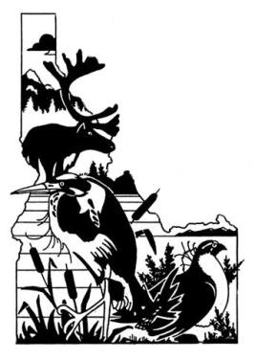
Idaho Chapter of The Wildlife Society
ICTWS Student Scholarship
OVERVIEW

The Wildlife Society Mission Statement: The mission of The Wildlife Society is to represent and serve the professional community of scientists, managers, educators, technicians, planners, and others who work actively to study, manage, and conserve wildlife and habitats worldwide. The Idaho Chapter of The Wildlife Society is a professional society dedicated to active and careful management and conservation of wildlife and their habitats in Idaho.

Objectives of the Idaho Chapter of The Wildlife Society:
a) To establish and maintain the highest possible professional standards,
b) To develop all phases of wildlife management along sound biological lines,
c) To express the unified opinion of the Chapter on wildlife resource matters of
local and national interest.

Scholarship Overview: The Idaho Chapter of The Wildlife Society established the Idaho Wildlife Undergraduate and Graduate Student Scholarships in 2012. The purpose of the scholarships is to assist with college education costs for undergraduate and graduate students whose professional goals support the mission and objectives of The Wildlife Society.

Eligibility Criteria:
- Current enrollment in a wildlife-related degree program at a college or university in Idaho. Undergraduate students must be in their junior or senior year.
- Career goals that advance the mission and objectives of The Wildlife Society.
- Current membership in the Idaho Chapter of The Wildlife Society.
- A good academic record, i.e., a minimum cumulative GPA of 3.0 out of 4.0.
- Has not been awarded this scholarship within the same degree program, i.e., only one award is possible during each undergraduate, Master’s, or PhD studies.

Amount: Undergraduate $1,500; MS $2,000; PhD $2,000

Selection Criteria (in order of relevance):
Undergraduate
- Relevant work, intern, or volunteer experience that demonstrates a career path in the wildlife profession
- Involvement in professional societies, conservation groups, and/or community activities
- Honors, awards, and acknowledgments related to the field of wildlife conservation
- Stated career goals and commitment towards a profession in wildlife conservation/management consistent with the mission of The Wildlife Society
- Academic record & GPA
- Strengths considered: degree plan or area of concentration; any research, publications, presentations, or poster

Graduate (MA/MS and PhD)
- Graduate research synopsis including project design, ingenuity, methods/likelihood of project implementation, and relevance to the field of wildlife conservation or management (Note: not to exceed 2 pages)
- Involvement in professional societies, conservation groups, and/or community activities, including mentoring others
- Relevant wildlife-related work, intern, or volunteer experience including quantity of positions, variety, and relevance to wildlife conservation or management
- Publications, presentations, and/or posters, particularly as lead author
- Honors, awards, and acknowledgements related to the field of wildlife conservation
- Stated career goals consistent with mission of The Wildlife Society
- Academic record & GPA

Application Process:
- Completed application form (available at: http://www.ictws.org/),
- Copy of resume and official college transcripts
- Statement of career goals (500 words or less)
- Letter of recommendation from a biology professor, faculty advisor, administrator or employer
- For graduate only: Brief summary of research project

Please scan and email all materials together in one application package to:

ICTWS Scholarship Committee
Robert Akins
robert.akins@idfg.idaho.gov

Application Deadline: January 26, 2024

Notification: Winners will be announced during the Business Lunch at the annual meeting of the Idaho Chapter of The Wildlife Society. Winners will also be notified directly by email.

Scholarship winners are encouraged to develop professional relationships by presenting their undergraduate project or graduate thesis research as a poster or presentation at an annual meeting prior to completing their studies.

Additional Information: For additional information, please contact the ICTWS Scholarship Committee Chair: Robert Akins (robert.akins@idfg.idaho.gov).

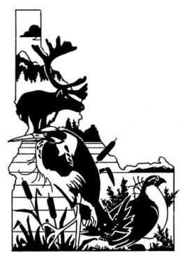
Idaho Chapter of The Wildlife Society
ICTWS Student Scholarship
APPLICATION FORM

Applying For:
Undergraduate Scholarship Graduate Scholarship MA/MS PhD

- Personal and Contact Information:

Student Name: ________________________________________________________________

Email Address: ________________________

- School Information

College/University: ___________________________ Major: ___________________________

Degree (BA / BS / MA / MS / PhD) Expected Graduation Date: ______________________

Year in Degree Program: _________ College Grade point average (GPA): ______________

Research Topic or Area of Emphasis: ______________________________________________

- Membership Information (check one)

Idaho Chapter TWS National TWS

Included with application package:
Resume College Transcripts Letter of Recommendation

Career Statement Graduate only: Synopsis of Research

Idaho Chapter of The Wildlife Society
ICTWS Student Scholarship
STATEMENT OF CAREER GOALS

Student Name: _________________________________________________________________

Please provide a statement outlining your career goals and reasons for pursuing a career in wildlife science. Please describe your role in promoting sound stewardship of the wildlife resource, and the environments upon which wildlife and humans depend. Be sure to mention activities in professional and honor societies, awards and acknowledgements related to wildlife conservation, work and volunteer experience, and any publications. Some of this information can be presented in a resume but when missing from career statement or resume, applications may be considered incomplete. The statement should be 500 words or less.
Idaho Chapter of The Wildlife Society
ICTWS Student Scholarship
LETTER OF RECOMMENDATION

Student Name: _________________________________________________________________

The above-named student is applying for a scholarship from the Idaho Chapter of The Wildlife Society. Please write a brief letter of recommendation (1-2 pages) and include the following:
- How you know the student,
- The student’s strengths,
- The student’s potential to succeed in a career in wildlife science, and
- Anything else you consider relevant. Please fill out the information below and attach your letter of recommendation to this form and return it to the student.

To be completed by person preparing the Letter of Recommendation:
Name: _______________________________________________________________________
Position: _____________________________________________________________________
Name of Affiliation: ____________________________________________________________
Email Address: ______________________________ Telephone Number: ________________
Signature: _______________________________________________ Date: _______________

