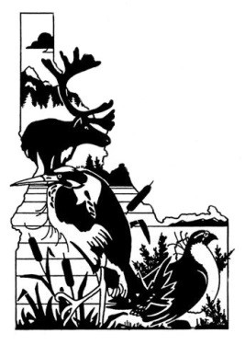
Idaho Chapter of The Wildlife Society

Student Travel Award

The Wildlife Society Mission Statement: The mission of The Wildlife Society is to represent and serve the professional community of scientists, managers, educators, technicians, planners, and others who work actively to study, manage, and conserve wildlife and habitats worldwide. The Idaho Chapter of The Wildlife Society is a professional society dedicated to active and careful management and conservation of wildlife and their habitats in Idaho.

Objectives of the Idaho Chapter of The Wildlife Society:
- To establish and maintain the highest possible professional standards,
- To develop all phases of wildlife management along sound biological lines,
- To express the unified opinion of the Chapter on wildlife resource matters of local and national interest

Student Travel Award Program: The purpose of the Student Travel Awards is to welcome and mentor the next generation of wildlife biologists and managers through offsetting some travel costs associated with ICTWS annual meeting attendance. For the 2024 annual meeting, ICTWS may distribute up to five (5) travel awards of $300 each.

Eligibility Criteria:
- Applicant must be a current student at a college or university in Idaho pursuing a wildlife conservation or natural resources related degree.
- Applicant must already have or obtain a current ICTWS student membership.

Application Process: Complete grant application (available below or at: https://wildlife.org/idaho-chapter/awards/ ) and submit as a .pdf via email to laura.wolf@idfg.idaho.gov. In the subject line of the email, note “ICTWS Student Travel Award Application”.

Application Deadline: Deadline is February 16th, 2024. Non-recipients of awards are encouraged to re-apply in succeeding years if eligibility requirements are met.

Evaluation Criteria: After the eligibility criteria, applications will be prioritized by 1) need and 2) level of participation in the ICTWS meeting. Participation may include oral or poster presentations, volunteering, joining a committee, enrolling in the student mentorship program.

Notification: Successful applicants will be notified via email by February 26, 2024. They can pick up their award at the registration desk at the annual meeting.

Additional Information: For additional information, please contact the ICTWS Grant Program Chair (Laura Wolf, laura.wolf@idfg.idaho.gov).

Idaho Chapter of The Wildlife Society

Student Travel Award Application

Name:
School:
School email:
Preferred email (if different):
Are you a current ICTWS student member?
Have you attended an ICTWS annual meeting before?
__________________________________________________________________
Statement of Financial Need:

__________________________________________________________________
Participation: Please check all that apply.
☐ Oral presentation ☐ Poster presentation ☐ Volunteer*
☐ Committee member ☐ Student mentorship program
*space is limited to the first twenty (20) volunteers who sign up.

If doing a presentation, please provide the citation(s) here:

