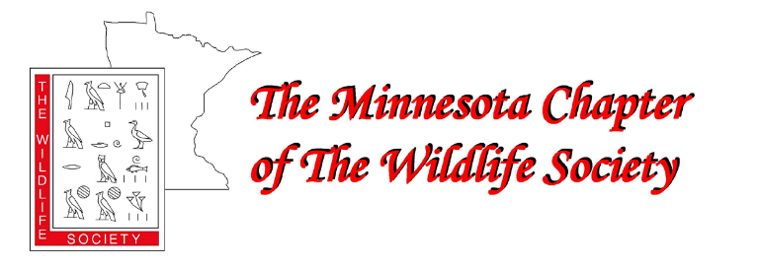

2024 ANNUAL MEETING

February 27-29th, 2024

Sanford Center, Bemidji, MN

Name: __________________________________________________ Pronouns:___________________________________

Address:

City: State: Zip:

Phone: E-mail:

Organization: Title:

Feel free to select a colored sticker for your name badge which will indicate your comfortability with social engagement.
_______ I am a professional member willing to engage with others openly and positively, including students (blue sticker).
_______ I am more introverted and would prefer someone friendly to initiate engagement (orange sticker).

Annual Meeting | Amount | Total Amount Due
Member Registration – Professional (In person) | $125
Non-Member Registration – Professional (In person) | $160
Student Registration (Includes 1-yr membership in MNTWS state chapter) | $60
Virtual Attendance Registration (via zoom) | $100
In person registration includes appetizers during Tuesday night’s Welcome Reception/Fundraiser; no other meals included.
Wednesday Awards Banquet – Professional/Non-Student | $25
Wednesday Awards Banquet – Student | $10
*Raffle Bucks Coupons (see page 2) | $5/each x #( )
Banquet prices represent ~35% and ~75% discount, respectively, from vendor’s prices. How’s that for a deal in the midst of inflation?!
Registration and banquet costs are non-refundable, however virtual meeting access will be provided if your travel plans change.
MN TWS Membership
Regular Membership | $25/year
Student Membership | Incl. w/registration | N/A
Retiree Membership | $15/year
Life Membership | $400
You can also become a member online by visiting https://wildlife.org/join/ or log in through your member portal to renew.

Payment Method (select one) Total Due: _______________
____ Credit Card: Scan this form and email it to reid.plumb87@gmailcom; he will then send you an invoice via email that can be paid via PayPal. If you are registering multiple people, please indicate if one person will be paying for the group or if each person needs to be invoiced separately.
____ Check or Cash: Mail this form and your payment to: Reid Plumb, 24634 County 9, Bemidji, MN 56601. Make checks payable to “Minnesota Chapter of The Wildlife Society” and record your check # here: _____________

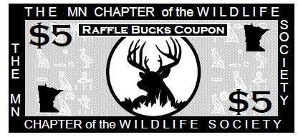
Purchase $25 worth of Raffle Bucks Coupons and receive a $5 BONUS Coupon ($30 value)
*Raffle Bucks Coupons can be used for all raffle ticket sales at the MN Chapter Annual Meeting fundraising event. Raffle items can include: a kayak, art prints, hand-carved decoys, and/or miscellaneous bucket raffle prizes. Raffle Bucks Coupons can be picked up at the registration desk on February 27 or during the fundraiser.

Guidelines for Professional Behavior at The Minnesota Chapter of The Wildlife Society Annual Meeting

The Minnesota Chapter of The Wildlife Society (MNTWS) annual meeting provides an important opportunity for education, exchange of ideas, mentoring young conservationists, networking with fellow wildlife professionals, and engagement with colleagues in a variety of ways. Our hope is that each attendee will benefit from their participation during the conference. Even as we recognize the importance of and strive for diversity in our natural world, we acknowledge the contribution of individual diversity to our profession. As stated in our long-standing Position Statement on Workforce Diversity in the Wildlife Profession, “The Wildlife Society recognizes the value of including the richness of human diversity in our efforts to discover, educate, inform policy, and involve the public in wildlife science and management.”

In this light and with the goal of ensuring that the annual conference is welcoming and inclusive for all, we put forward the following guidelines for professional behavior during the annual conference:

- All participants should be treated with respect and consideration, valuing the diversity of views and opinions that may be different than those you hold
- Communicate with respect for others; critique ideas rather than individuals
- Avoid personal attacks directed towards conference participants
- Be mindful of your colleagues and your surroundings
- Professionalism should be exercised at all time

The following are examples of behavior that will not be tolerated at the annual conference, including oral and poster sessions and other organized meetings whether at the conference center or off-site:

- Harassment, threats, intimidation, or discrimination of any kind or in any form
- Physical or verbal abuse
- Verbal comments related to gender, sexual orientation, disability, physical appearance, race, religion, political affiliation, or national origin which may reasonably be interpreted as offensive, insulting, or obscene or engaging in any conduct of a stalking or threatening nature directed to any conference participant or attendee
- Behavior deemed to be excessively loud and/or disruptive of a meeting or any other event taking place during the annual conference
- Unlawful conduct or activity of any kind

Reporting of Inappropriate Behavior:

- If you are the subject of or witness conduct in violation of these guidelines at the annual conference, please notify a MNTWS Governing Board member or a member of the MNTWS DEI Committee.
- TWS will use reasonable efforts to respond and attempt to resolve the matter in a timely manner respectful of the parties and necessary to ensure the continued integrity and quality of the meeting.
- Anyone experiencing or witnessing behavior that constitutes an immediate or serious threat to public safety at our annual meeting in the convention center or hotel is advised to locate a house phone and ask for security or dial 911.

TWS at all times reserves the right, in its sole and reasonable discretion, to have individuals acting in an unprofessional manner or contrary to these guidelines removed from the meeting or event taking place at the conference and the right to prohibit attendance at any future meeting. Attendance at the Minnesota Chapter of TWS annual meeting is a privilege, not a right.

We appreciate your attention to these guidelines and wish you a productive and meaningful annual meeting.

