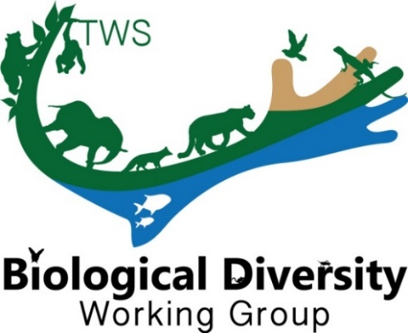
THE WILDLIFE SOCIETY
BIOLOGICAL DIVERSITY WORKING GROUP

The Biological Diversity Working Group (BDWG) is offering Student Travel Grants (up to $500) to help students attend the 2023 TWS Annual Conference in Louisville, KY!

Be sure to apply no later than September 1st. Let us know if you have any questions.

Eligibility
All applicants must be a member in good standing with The Wildlife Society (but are not required to be a member of the BDWG) and have been accepted to present a paper/poster at the 2023 TWS Annual Conference. This is a merit-based award that will be scored based on the categories: 1) contact information, 2) abstract, 3) membership, 4) involvement, and 5) relevance.

**APPLICATION:
Submit application, as a Word or PDF file, directly to the BDWG (twsbdwg@gmail.com) no later than September 1, 2023. Place “Student Travel Grant” in the subject line of the email.

Contact Information
Date of Application:
Student’s Name:
Institution and Address:
Phone:
E-mail:
Abstract
Presentation Title:
Authors:
Current Category:
Presentation Type:
Abstract:
Membership (Please state if you [the student] are a current member of the BDWG; BDWG membership is not required, but applications from a member will receive priority. You can join BDWG anytime via your TWS Member Portal.):
Involvement (Please explain how you plan to be involved with BDWG activities during the 2023 TWS meeting and beyond; for example, attend the BDWG annual meeting and/or sponsored symposia/workshops, nominate yourself or others for a board position, interact on our Facebook page - https://www.facebook.com/BiodiversityWG/ or Twitter - @TWS_BDWG, etc):
Relevance (Please explain the alignment of the presentation and research with the mission and goals of BDWG; which can be found at our website- www.wildlife.org/bdwg):

Funding (Please list any secured or potential alternative sources of funding):

