Kirk Stodola (Candidate for President-Elect)
Current Position: Assistant Population Ecologist, Illinois Natural History Survey; Adjunct Professor, Department of Natural Resources and Environmental Sciences, University of Illinois, Urbana, IL
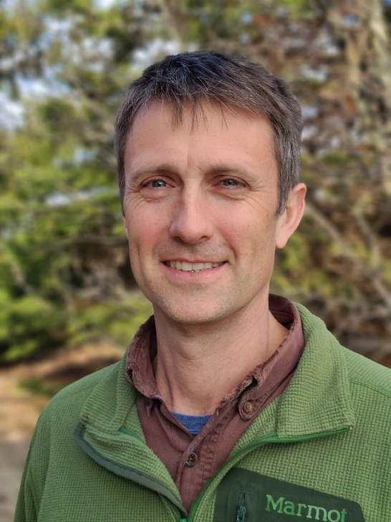
Education: B.S. in Wildlife Ecology - University of Wisconsin, Madison, WI; M.S. Biological Sciences – Mississippi State University, Starkville, MS; Ph.D. in Forest Resources – University of Georgia, Athens, GA
Personal Background: I grew up in the Twin Cities, Minnesota where I spent of lot of time fishing in my grandpa’s boat and making camping trips up north when I became old enough to drive. I enjoyed anything outdoors, playing various sports, canoeing, camping, etc. but never you knew you could do that stuff for a living. In fact, I didn’t even know this field existed until my sophomore year zoology class, where I met a graduate student who told me he was getting paid to study fish. Once I heard that, I was in! I got involved with the student chapter of the Wildlife Society at the University of Wisconsin-Madison and did some really fun stuff-- prescribed burns, small mammal trapping, crane counts, etc. Following graduation, I bounced around the country doing various wildlife related jobs, until it was time to get serious in this field and continue my education. I met my wife in graduate school at the University of Georgia and followed her to Illinois, where we are both biologists (her with freshwater organisms) with the Illinois Natural History Survey. We have a four- and six-year-old that we schlep with us on weekend hiking, camping, and exploring trips and still get out to area lakes in my grandpa’s boat, which is now ours. Aside from those endeavors, I enjoy daily runs with my dog, long bike rides, and the occasional upland or waterfowl hunt.
Work History: Once I found out you could get paid to work with wildlife, I tried taking advantage of all the opportunities this field affords. I have worked many technician jobs: nest searching in Wisconsin and Arizona, point counts in the White Mountains of New Hampshire, and arthropod sampling in southern Arizona to name a few. I was a full-time employee of the Peregrine Fund for a couple years, helping to reintroduce Aplomado Falcon into south Texas and California Condor into the Grand Canyon area of northern Arizona and Utah. My work has mainly centered on bird-related projects. My graduate research focused on forest interior songbirds and various aspects influencing their populations, in particular the effects of the non-native hemlock woolly adelgid and the loss of the Eastern Hemlock. However, I have diversified my experiences in my current job and I have been a part of projects ranging from ducks and shorebirds to mesopredators to freshwater mussels. I also teach two graduate courses at the University of Illinois, Applied Ecology and Population Estimation, and have had the pleasure of working with numerous students in developing projects and analyzing data from those projects. I have really enjoyed these aspects of my current position.
Views: I am very applied and pragmatic in my interests, as I prefer to work on issues that directly inform management and/or improve efficiency. Consequently, I believe my views are in line with much of what ICTWS stands for, sound stewardship, preventing environmental degradation, the value of wildlife, and high standards in research and practice. I also think the Society as a whole, and the Illinois Chapter, offer a natural bridge between academia and practitioners and I would like to continue and foster this relationship. The other role of ICTWS that I would like to highlight is one of opportunity. I greatly benefited from the experiences offered by the student chapter at the University of Wisconsin and want others to have similar opportunities. I believe ICTWS can play an important role in increasing the accessibility of this field to students. ICTWS is a great conduit for integrating our diverse student chapters and helping students get hands on experience doing many of the fun things we do in the field of wildlife.

