Justin J. Shew (Candidate for President-Elect)
Current Position: Conservation Program Manager at The National Great Rivers Research and Education Center (NGRREC), Lewis & Clark Community College (Godfrey, IL); Adjunct Professor of Ecology and Undergraduate Research Mentor, Webster University (Webster Groves, MO).
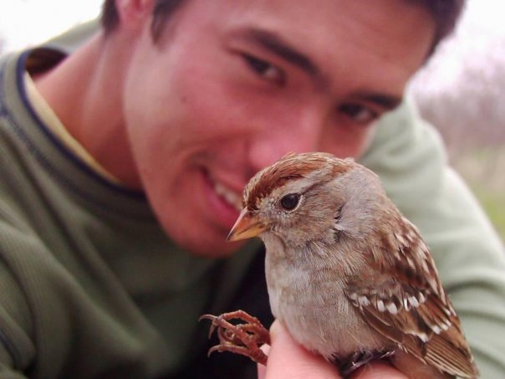
Education: B.S. in Biology, Truman State University (Kirksville, MO); M.S. in Biology, Missouri State University (Springfield, MO); Ph.D. in Zoology (Wildlife Ecology), Southern Illinois University Carbondale
Personal Background: Justin grew up in the suburbs of St. Louis, MO and always had an interest in the outdoors and wildlife. Despite having traveled the country and parts of the world (i.e. Anguilla, Newfoundland, and South Africa) to do wildlife research/education/technician work, Justin is back in St. Louis, MO to be close to his immediate family and ensure his five-year-old daughter develops a relationship with them. In Justin’s spare time he loves to plan camping trips with family and friends and plays music on his multiple ukuleles and guitar.
Work History: Dr. Shew became conservation program manager at NGRREC (East Alton, IL) in April 2016 before finishing his doctoral at Southern Illinois University Carbondale in December 2016. His doctorate work on grassland bird response to management on private lands in Illinois and his experience managing a four-person field crew for four field seasons helped him move into his current position. Justin has a more non-traditional background from most PhDs as he spent six years working after completing his Masters on the spatial ecology of fox snakes before deciding to go back to graduate school for his doctoral. During this time, he gained valuable experience working on avian projects from California to South Africa with various organizations and was also a full-time biologist-educator for Audubon California of The National Audubon Society. At Justin’s current position his most rewarding experiences have been mentoring undergraduates and seeing them gain confidence and present their work - one of these students even presented their work at the annual ICTWS meeting.
Views: I’ve only known ICTWS and never was presented an option to join a student chapter in Missouri during the time I was pursuing my undergraduate and Master’s degrees. I’m seeing the real value of TWS as I’ve been able to grow, not only as professional, but as a person from my experience as member of the 2019 Leadership Institute Class. I’ve always appreciated IL’s smaller chapter meeting, which has a heavy emphasis on students, where I actually get to have meaningful conversations with other student and colleagues. As president-elect I want to bring more training and development opportunities to both students and professionals to our annual meeting and beyond - hopefully encouraging greater membership to our chapter. Among this goal would also to continue to have the difficult conversations on how our chapter and profession can improve diversity and inclusion among its members.

