Annual Membership Meeting Wednesday February 22nd 1:30 – 3:30 PM

Call to Order -Bruce Anderson

President’s Report – Bruce Anderson. Introduction of the Board of Directors and Committee Chairs.
- Thank you to Supporters, Vendors and Partners.
- Strategic Goals
  - Concerns
  - Membership Survey Results

President-Elect’s Report- Nicole Bernd

- 2023 Annual Meeting Tentative expenditures vs. income

Secretary’s Report – Kat Dickerson

Treasurer’s Report – Bruce Anderson

- See attached Treasurer's Report

2022 Accomplishments-Committee Updates
- 2022 Summer Workshop-Nicole Davros and Kristin Hall
- Fund Raising Committee- Sheldon Myerchin, Dawn Plattner & Martha Minchak
- Membership Committee-Jessica Piispanen and John Loegering
- DEI Committee-Megan Howard, Nicole Davros & Mark Hove
- COWCH-Andy Tri
- Non-Toxic Workgroup-Brian Hiller and Steve Windels
- Forest Issues Committee- Chris Smith, Brian Hiller and Bruce Anderson
- Historian/Archivist-John Moriarty
- Awards Committee-Steve Windels
- Student Relations Committee – Joey Riley
- Student Chapters and Advisor
  - Vermillion Community College-Ryan Miller
  - Bemidji State University-Brian Hiller and Jacob Haus
  - MN State University-Donna Stockrahm
  - UMN-Twin Cities-Mark Hove and James Forester
  - Central Lakes College-Bill Faber
  - UMN-Crookston-John Loegering
Election Results – Brian Hiller
- President Elect
- Secretary
- Treasurer (vice Bill S.)
- Members at Large (2)

President's Final Remarks – Bruce Anderson

Presidential Authority Passed to New President – Nicole Bernd

NEW BUSINESS

2023 Summer Workshop – Reid Plumb and Molly Tranel

Open Floor Discussion

3:30-Adjourn.

GOVERNING BOARD – 2022

Executive Board
- President-Bruce Anderson
- President-elect-Nicole Bernd
- Past President-Brian Hiller
- Secretary – Kat Dickerson
- Treasurer – Bill Severud then Bruce Anderson-Acting

Board Member at Large
- Kristen Hall
- Reid Plumb
- Nicole Davros
- Molly Tranel

Committee Chairs
- Audit-Gretchen Mehmel
- Awards-Steve Windels
- COWCH-Andy Tri
- Newsletter Editor-Laurie Fairchild
- Webmaster-Kat Dickerson
- Fundraising-Sheldon Myerchin and Dawn Plattner
- Forest Issues-Chris Smith and Bruce Anderson
- Historian/Archivist-John Moriarty
- Membership-Jessica Piispanen and John Loegering
- Non-Toxic Workgroup-Brian Hiller and Steve Windels
- Prairie/Farmland Issues-Jake Nelson
- Statewide Issues- Unknown
- Student Relations-Joey Riley
- Wetland Issues-Marsha Barnes?

Representatives
- Minnesota Conservation Federation-Bill Faber
- State Technical Committee Representative- Unfilled
- Conservation Affairs Network-Unfilled
Presidents Report Attachments

Strategic Goals

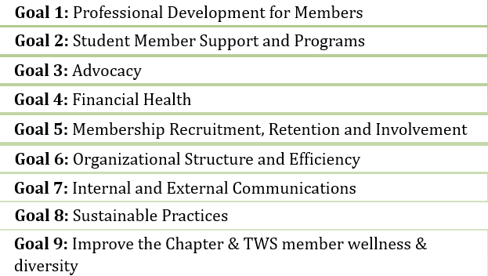

2020 Membership Survey

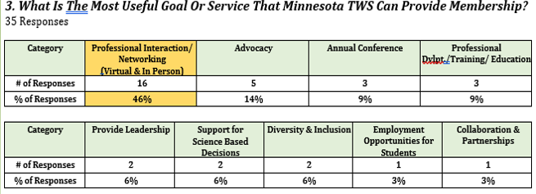

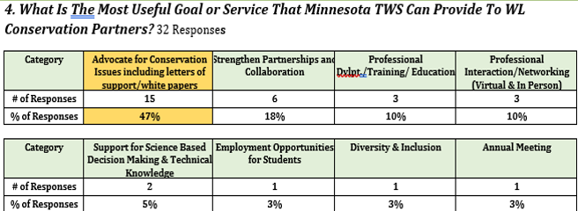

2020 Membership Survey-Continued

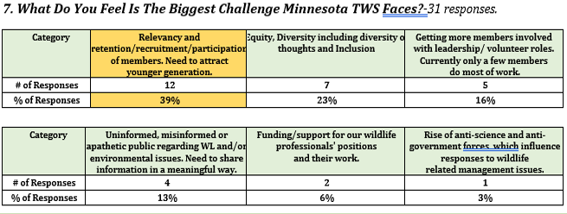

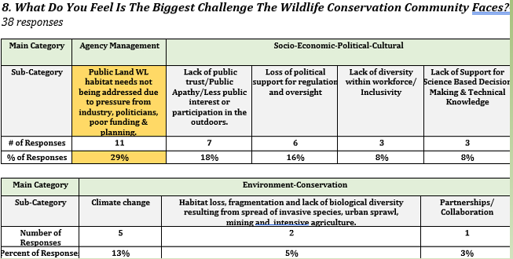
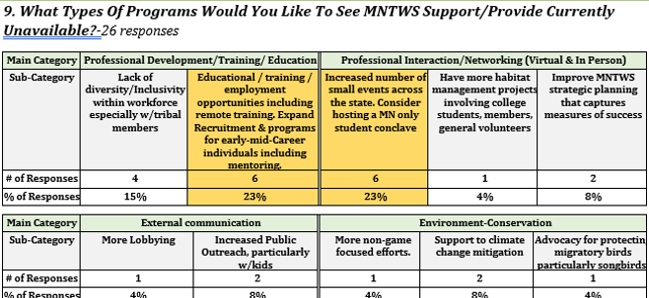
2020 Membership Survey-Continued

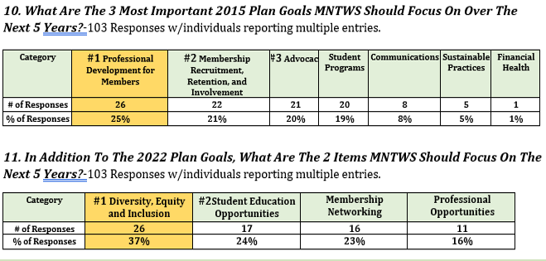

Committee Reports and Accomplishments

2022 Summer Workshop. Nicole Davros and Kristin Hall

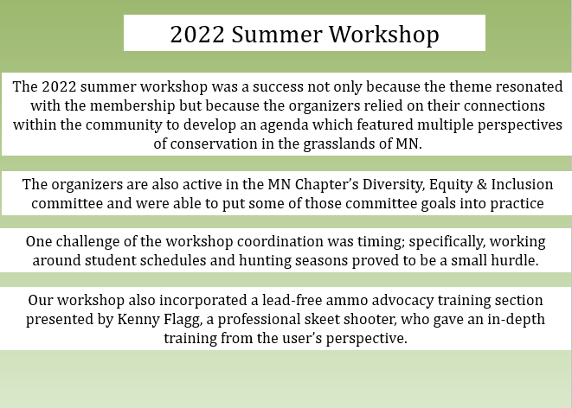

Membership Committee-Jessica Piispanen & John Loegering

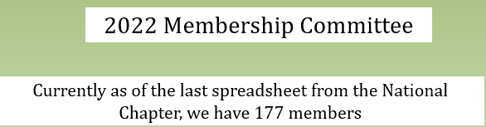
DEI Committee-Meaghan Howard, Nicole Davros, Kristin Hall, Mark Hove et. al.

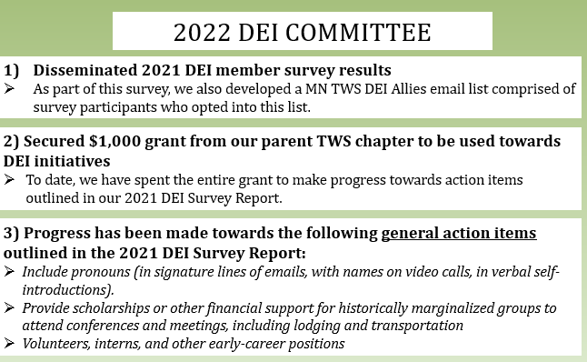
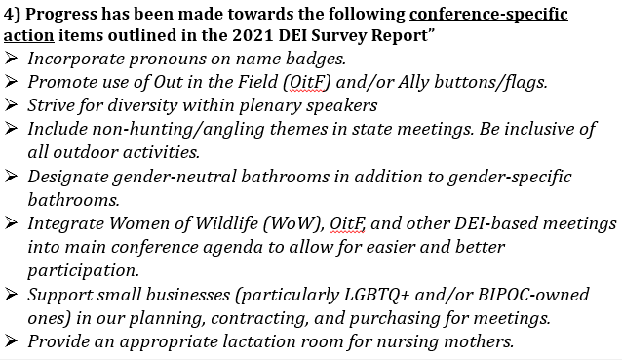

COWCH Committee-Andy Tri et al.

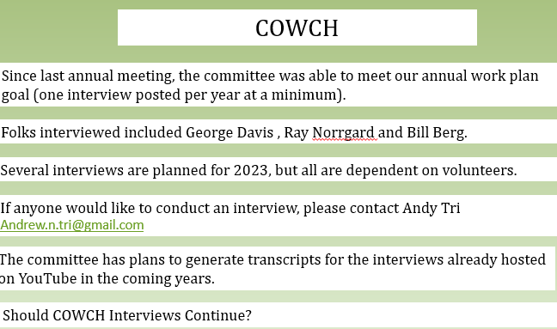

Non-Toxic Ammo Committee-Steve Windels, Brian Hiller and Kenny Flagg

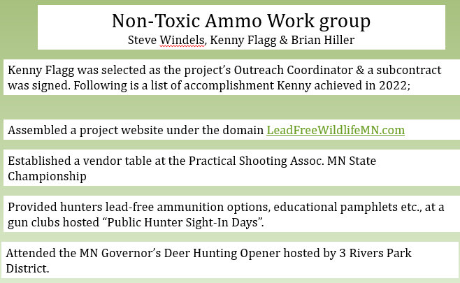
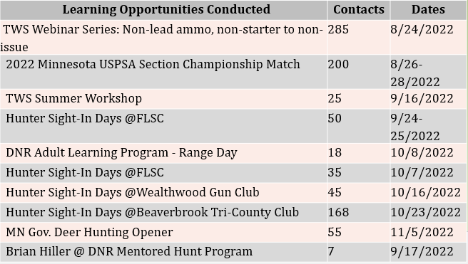

Forest Committee-Brian Hiller, Chris Smith and Bruce Anderson

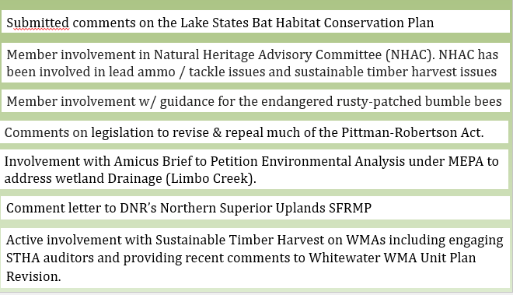

Awards Committee-Steve Windels

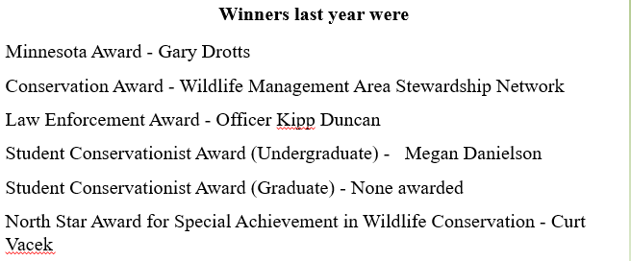

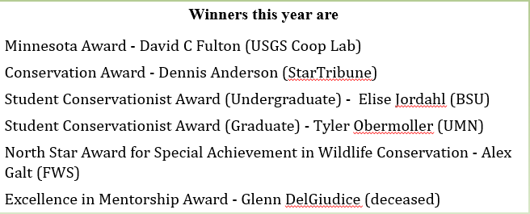

Student Relations Committee-Joey Riley and Brian Hiller

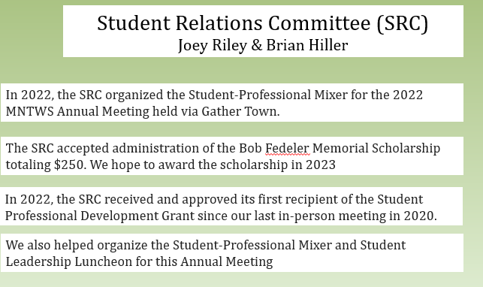

 | Calendar Year 2022 Treasurer’s-Acting Treasurer-Bruce Anderson
 | Reward Checking. 0.13% interest
 | Date | Description | Details | Debits | Credits | Balance
 | 1ST QUARTER
 | 1/1/2022 | 2022 Beginning Balance |  |  |  | $ 13,146.47
 | 1/31/2022 | Split Rate APY Earned 0.13% 01/01/22 to 01/31/22 |  |  | $ 1.40 | $ 13,147.87
 | 1/31/2022 | The Wildlife Soc : Bill.com ID: x5317CO: | The Wildlife Soc ACH ECC CCD ACH |  | $ 1,430.00 | $ 14,577.87
 | 2/8/2022 | #031514 GATHER HTTPSGATHER.T CA Card 15 #8242 |  | $ 2,100.00 |  | $ 12,477.87
 | 2/11/2022 | The Wildlife Soc : Bill.com ID: x5317CO: The Wildlife Soc ACH ECC CCD ACH Trace x022642601 | Pheasants Forever sponsorship |  | $ 250.00 | $ 12,727.87
 | 2/19/2022 | Deposit by Check |  |  | $ 250.00 | $ 12,977.87
 | 2/28/2022 | Split Rate APY Earned 0.12% 02/01/22 to 02/28/22 |  |  | $ 1.27 | $ 12,979.14
 | 3/2/2022 | Check # 0000001444 | Awards trophies | $ 939.89 |  | $ 12,039.25
 | 3/2/2022 | Check # 0000001445 | Awards shipping | $ 169.74 |  | $ 11,869.51
 | 3/4/2022 | USPS PO 26835100 2000 COUNTY ROAD B PAUL MN Card 8242 | Stamps | $ 23.20 |  | $ 11,846.31
 | 3/4/2022 | ATM AFFINITY PLUS 2750 SNELLING AVE ROSEVILLE MN XK4826 CHECK DEP Card 8242 | Annual meeting registration |  | $ 50.00 | $ 11,896.31
 | 3/4/2022 | ATM AFFINITY PLUS 2750 SNELLING AVE ROSEVILLE | Annual meeting registration |  | $ 50.00 | $ 11,946.31
 | 3/4/2022 | PAYPAL : TRANSFER ID: PAYPALSD11 CO: PAYPALAMT: 4,672.65 ACH | PPD ACH Trace x017541291 |  | $ 4,672.65 | $ 16,618.96
 | 3/9/2022 | Check # 0000001447 | Honoraria for D. Tallamy | $ 500.00 |  | $ 16,118.96
 | 3/9/2022 | Check # 0000001449 | Grad student best poster | $ 100.00 |  | $ 16,018.96
 | 3/11/2022 | Check # 0000001448 | Honoraria for D. Truer | $ 5,000.00 |  | $ 11,018.96
 | 3/18/2022 | Check # 0000001446 | Student Conservationist Award | $ 100.00 |  | $ 10,918.96
 | 3/23/2022 | Check # 0000001452 | Undergrad best poster ( for 2 coauthors) | $ 50.00 |  | $ 10,868.96
 | 3/24/2022 | Check # 0000001454 | MN Sharptail Grouse Sponsorship | $ 250.00 |  | $ 10,618.96
 | 3/24/2022 | Check # 0000001453 | Undergrad best poster | $ 50.00 |  | $ 10,568.96
 | 3/31/2022 | Split Rate APY Earned 0.13% 03/01/22 to 03/31/22 |  |  | $ 1.30 | $ 10,570.26
2ND QUARTER
4/1/2022 |  | Beginning Balance |  |  |  | $ 10,570.26
4/20/2022 |  | The Wildlife Soc : Bill.com ID: 1204895317: | The Wildlife Soc ACH ECC CCD ACH Trace |  | $ 1,020.00 | $ 11,590.26
4/26/2022 |  | Deposit by Check. |  |  | $ 620.00 | $ 12,210.26
4/27/2022 |  | Check 1451 Tracer 815300000000042 | Check to Michael McMahon | $ 100.00 |  | $ 12,110.26
4/30/2022 |  | Deposit Dividend Split Rate |  |  | $ 1.13 | $ 12,111.39
5/3/2022 |  | Check 1450 | Check to Christina Wilke. Tracer | $ 100.00 |  | $ 12,011.39
5/19/2022 |  | Check 1455 | Tracer 817500000002450 | $ 275.00 |  | $ 11,736.39
5/23/2022 |  | Deposit at ATM #009464 | AFFINITY PLUS ROSEVILLE |  | $ 25.00 | $ 11,761.39
5/24/2022 |  | Deposit ACH PAYPAL | TRANSFER ID: PAYPALSD11. |  | $ 62.23 | $ 11,823.62

Reward Checking. 0.13% interest. Continued
Date |  | Description | Details | Debits | Credits | Balance
5/31/2022 |  | Deposit Dividend Split Rate |  |  | $ 1.27 | $ 11,824.89
6/8/2022 |  | Check 1456 | Check to Northern Consultants. | $ 800.00 |  | $ 11,024.89
6/13/2022 |  | Deposit ACH PAYPAL | PAYPALSD11 |  | $ 48.02 | $ 11,072.91
6/15/2022 |  | Deposit by Check |  |  | $ 25.00 | $ 11,097.91
6/29/2022 |  | Deposit ACH The Wildlife Soc | TYPE: Bill.com ID: 1204895317 |  | $ 1,000.00 | $ 12,097.91
6/30/2022 |  | Deposit Dividend Split Rate | Annual Percentage Yield Earned: 0.120% |  | $ 1.16 | $ 12,099.07
3RD QUARTER
7/1/2022 |  | Beginning Balance |  |  |  | $ 12,099.07
7/19/2022 |  | Deposit ACH PAYPAL. | ACH Trace Number: 091000015409491 |  | $ 14.21 | $ 12,113.28
7/20/2022 |  | Deposit by Check. #1325 | MN sharptailed Grouse Society |  | $ 200.00 | $ 12,313.28
7/25/2022 |  | Deposit ACH | Deposit ACH The Wildlife Soc |  | $ 355.00 | $ 12,668.28
7/31/2022 |  | Annual Percentage Yield Earned: 0.120% | Annual Percentage Yield Earned: 0.120% |  | $ 1.30 | $ 12,669.58
8/8/2022 |  | Deposit from MNTWS Workshop sponsors. Check#1187 & 4951) | NAGP & MPCS |  | $ 350.00 | $ 12,669.58
8/12/2022 |  | Withdrawal for Contractor | Northern Wildlife Consultants | $ 800.00 |  | $ 13,019.58
8/13/2022 |  | Withdrawal Debit Card. | BUILDASIGN.COM 800-330-9622 TX | $ 64.42 |  | $ 12,219.58
8/24/2022 |  | Deposit ACH. | Deposit ACH PAYPAL |  | $ 101.44 | $ 12,155.16
8/25/2022 |  | Deposit by Checks from MNTWS Workshop attendees. | Checks from B. Anderson & A. Knutson |  | $ 55.00 | $ 12,256.60
8/31/2002 |  | Deposit Dividend Split Rate | APR Yield Earned: 0.130%... |  | $ 1.32 | $ 12,311.60
8/31/2022 |  | Closing Date Balance |  |  |  | $ 12,312.92
9/12/2022 |  | Deposit by Checks from MNTWS Workshop attendees. | Workshop attendees regristration fees | $ | $ 150.00 | $ 12,312.92
9/13/2022 |  | Deposit ACH PAYPAL from Workshop Attendees | Workshop attendees regristration fees |  | $ 578.73 | $ 12,462.92
9/14/2022 |  | Summer Workshop Food Caterer | Kafe La Baja. MNTWS Check # 1458. | $ 500.00 |  | $ 13,041.65
9/16/2022 |  | Summer Workshop Diversity Buttons | HIGHLIGHT PRINTING MPS MN | $ 205.00 |  | $ 12,541.65
9/19/2022 |  | Deposit by Checks from MNTWS Workshop attendees. | Workshop attendees regristration fees |  | $ 85.00 | $ 12,336.65
9/23/2022 |  | Non-Lead Ammo Contractor. Check #1459 | Kenny Flagg-LankyInstruction. MNTWS | $ 2,037.00 |  | $ 12,421.65
9/28/2022 |  | Summer Workshop Travel Reimbursement for MNTWS President | Travel Reimbursement Check #1460 | $ 188.00 |  | $ 10,384.65
9/29/2022 |  | MNTWS Summer Workshop Sponsor-PF | MNTWS Summer Workshop Sponsor- |  | $ 300.00 | $ 10,196.65
9/30/2022 |  | Deposit Dividend Split Rate | APR Earned: 0.130%... |  | $ 1.22 | $ 10,497.87
4TH QUARTER
10/1/2022 | Beginning Balance |  |  |  |  | $ 10,497.87
10/17/2022 | Check 1462 Tracer 832600000000265 |  | Kenny Flagg-Lanky Instruction | $ 2,026.24 |  | $ 8,471.63
10/18/2022 | Deposit ACH PAYPAL |  | ACH Trace Number: 091000012980952 |  | $ 206.78 | $ 8,678.41
10/20/2022 | Check 1461 Tracer 832900000001487 |  | IDEA Working Group | $ 500.00 |  | $ 8,178.41
10/21/2022 | Deposit by Check |  | TWS annual meeting registration for B.Hiller |  | $ 100.00 | $ 8,278.41
10/25/2022 | Deposit ACH The Wildlife Soc |  | ACH Trace Number: 021000021776674 |  | $ 375.00 | $ 8,653.41
10/26/2022 | Check 1464 Tracer 833500000000257 |  | Northern Wildlife Consultants | $ 800.00 |  | $ 7,853.41

Reward Checking. 0.13% interest. Continued
Date |  | Description | Details | Debits | Credits | Balance
10/27/2022 |  | Withdrawal Home Banking Transfer To Share 0400 | VENMO-Steve Windels | $ 2,996.03 |  | $ 4,857.38
10/28/2022 |  | Withdrawal Debit Card | ZOOM.US 888-799-9666 WWW.ZOOM. | $ 161.71 |  | $ 4,695.67
10/31/2022 |  | Deposit Dividend Split Rate |  |  | $ 0.94 | $ 4,696.61
11/1/2022 |  | Beginning Balance |  |  |  | $ 4,696.61
11/11/2022 |  | Deposit Home Banking Transfer from Share 0001 | Transferred from Savings to ensure sufficient funds in checking. |  | $ 5,000.00 | $ 9,696.61
11/14/2022 |  | Deposit by Check |  |  | $ 5,663.44 | $ 15,360.05
11/15/2022 |  | Check 1466 Tracer 835500000004398 | Kenny Flagg-Lanky Instruction | $ 5,034.97 |  | $ 10,325.08
11/16/2022 |  | Check 1467 Tracer 835600000000059 | Northern Wildlife Consultants | $ 928.21 |  | $ 9,396.87
11/23/2022 |  | Withdrawal ACH HARLAND CLARKE | TYPE: CHK ORDERS ID: 5580278260 | $ 17.70 |  | $ 9,379.17
11/30/2022 |  | Deposit Dividend Split Rate | APR Yield Earned from 11/01-11/30 |  | $ 0.83 | $ 9,380.00
12/1/2022 |  | Beginning Balance |  |  |  | $ 9,380.00
12/1/2022 |  | Check 1468 Tracer 837100000000194 | Northern Wildlife Consultants | $ 1,420.00 |  | $ 7,960.00
12/5/2022 |  | Deposit by Check |  |  | $ 5,746.45 | $ 13,706.45
12/14/2022 |  | Check 1469 Tracer 838400000000197 | Northern Wildlife Consultants | $ 65.00 |  | $ 13,641.45
12/29/2022 |  | Check 1501 Tracer 839900000005466 | Reimbursement for Nicole Davrol | $ 102.67 |  | $ 13,538.78
12/30/2022 |  | Withdrawal POS #783112 | GoFundMe Redwood City CA | $ 28.75 |  | $ 13,510.03
12/30/2022 |  | Deposit by Checks | . A.Mtng Registration & Sponsorships. |  | $ 4,104.94 | $ 17,614.97
12/31/2022 |  | Deposit Dividend Split Rate | APR from 11/01 through 11/30 |  | $ 1.40 | $ 17,616.37
12/31/2022 |  | 2022 Ending Balance |  |  |  | $ 17,616.37
Checking - Midwest Steering Committee Funds
1ST QUARTER
1/1/2022 | 2022 Beginning Balance |  |  |  |  | $ 22,146.65
1/31/2022 | 0.050% APY Earned 0.05% 01/01/22 to 01/31/22 |  |  |  | $ 0.94 | $ 22,147.59
2/28/2022 | 0.050% APY Earned 0.05% 02/01/22 to 02/28/22 |  |  |  | $ 0.85 | $ 22,148.44
3/31/2022 | 0.050% APY Earned 0.05% 03/01/22 to 03/31/22 |  |  |  | $ 0.94 | $ 22,149.38
2ND QUARTER
4/1/202 | Beginning Balance |  |  |  |  | $ 22,149.38
4/30/2022 | Deposit Dividend 0.050% |  |  | $ - | $ 0.91 | $ 22,150.29
5/31/2022 | Deposit Dividend 0.050% |  |  |  | $ 0.94 | $ 22,151.23
6/30/2022 | Deposit Dividend 0.050% |  |  |  | $ 0.91 | $ 22,152.14
3RD QUARTER
7/1/2022 | Beginning Balance |  |  |  |  | $ 22,152.14
7/31/2022 | Deposit Dividend 0.050% |  | Deposit Dividend 0.050% | $ | $ 0.94 | $ 22,153.08
8/31/2022 | Deposit Dividend 0.050% |  | Deposit Dividend 0.050% |  | $ 0.94 | $ 22,154.02
9/30/2022 | Deposit Dividend 0.050% |  | Deposit Dividend 0.050% |  | $ 0.91 | $ 22,154.93

Checking - Midwest Steering Committee Funds-Continued
4th QUARTER
Date | Description | Details | Debits | Credits | Balance
10/1/2022 | Beginning Balance |  |  |  | $ 22,154.93
10/25/2022 | Withdrawal VENMO NAME: STEVEN WINDELS | This debit should have been from Interest Reward Checking (0200) | $ 2,996.03 |  | $ 19,158.90
10/27/2022 | Deposit Home Banking Transfer From Share 0200 | Reimbursement from Interest Rewards Checking (see 10/25/22 transaction) |  | $ 2,996.03 | $ 19,158.90
10/28/2022 | Deposit Home Banking Transfer From Share 0001 | Duplication of 10/27/22 transaction. This to be transferred back into 001 |  | $ 2,996.03 | $ 19,158.90
10/31/2022 | Deposit Dividend 0.050% | For the Period from 10/01 through 10/31 |  | $ 0.95 | $ 19,158.90
11/1/2022 | Beginning Balance |  |  |  | $ 19,158.90
11/11/2022 | Withdrawal Home Banking Transfer To Share 0001 |  | $ 2,996.03 |  | $ 22,155.88
11/30/2022 | Deposit Dividend 0.050% | For the Period from 11/01- 11/31 |  | $ 0.95 | $ 22,155.88
12/1/2022 | Beginning Balance |  |  |  | $ 22,155.88
12/31/2022 | Deposit Dividend 0.050% | For the Period from 11/01 -11/31 |  | $ 0.94 | $ 22,155.88
12/31/2022 | 2022 Ending Balance |  |  |  | $ 22,155.88
Savings 0.100% interest
1ST QUARTER
1/1/2022 | 2022 Beginning Balance |  |  |  | $ 32,247.02
1/1/2022 | Beginning Balance |  |  |  | $ 32,247.02
1/31/2022 | 0.100% APY Earned 0.10% 01/01/22 to 01/31/22 |  |  | $ 2.74 | $ 32,249.76
2/28/2022 | 0.100% APY Earned 0.10% 02/01/22 to 02/28/22 |  |  | $ 2.47 | $ 32,252.23
3/31/2022 | 0.100% APY Earned 0.10% 03/01/22 to 03/31/22 |  |  | $ 2.74 | $ 32,254.97
2nd QUARTER
4/1/2022 | Beginning Balance |  |  |  | $ 32,254.97
4/30/2022 | 0.100% APY Earned 0.10% 04/01/22 to 04/30/22 |  |  | $ 2.65 | $ 32,257.62
5/31/2022 | 0.100% APY Earned 0.10% 05/01/22 to 05/30/22 |  |  | $ 2.74 | $ 32,260.36
6/30/2022 | APY Earned: 0.100%. 6/1/22 to 6/30/2022 |  |  | $ 2.65 | $ 32,263.01
3rd QUARTER
7/1/2022 | Beginning Balance |  |  |  | $ 32,263.01
7/31/2022 | 0.100% APY Earned 0.10% 07/01/22 to 07/31/22 |  |  | $ 2.74 | $ 32,265.75
8/31/2022 | 0.100% APY Earned 0.10% 08/01/22 to 08/31/22 |  |  | $ 2.74 | $ 32,268.49
9/30/2022 | 0.100% APY Earned 0.10% 09/01/22 to 09/30/22 |  |  | $ 2.65 | $ 32,271.14
4th QUARTER
10/1/2022 | Beginning Balance |  |  |  | $ 32,271.14
10/28/2022 | Withdrawal Home Banking Transfer To Share 0400 | This debit should have been Checking (0200) | $ 2,996.03 |  | $ 29,275.11
10/31/2022 | 0.100% APY Earned 0.10% 10/01/222 to 10/31/22 |  |  | $ 2.71 | $ 29,277.82
11/1/2022 | Beginning Balance |  |  |  | $ 29,277.82
11/11/2022 | Deposit Home Banking Transfer From Share 0400 | Reimbursement from Interest Midwests Checking (0400). See 10/28/22 transaction |  | $ 2,996.03 | $ 32,273.85
11/11/2022 | Withdrawal Home Banking Transfer To Share 0200 | From Savings to ensure sufficient funds in 001 | $ 5,000.00 |  | $ 27,273.85
Savings 0.100% interest Continued
Date | Description | Details | Debits | Credits | Balance
11/30/2022 | 0.100% APY Earned 0.10% 10/01/222 to 10/31/22 |  |  | $ 0.95 | $ 27,274.80
12/1/2022 | Beginning Balance |  |  |  | $ 27,274.80
12/31/2022 | 0.100% APY Earned 0.10% 10/01/222 to 10/31/22 | 0.100% APY Earned 0.10% 10/01/222 to 10/31/22 |  | $ 2.32 | $ 27,277.12
12/31/2022 | 2022 Ending Balance |  |  |  | $ 27,277.12
60 Month Step-Up CD (Lifetime Membership Funds)
1/1/2022 | 2022 Beginning Balance |  |  |  | $ 5,231.20
1/1/2022 | Beginning Balance |  |  |  | $ 5,231.20
1/31/2022 | 1.982% APY Earned 2.00% 01/01/22 to 01/31/22 |  |  | $ 8.81 | $ 5,240.01
2/28/2022 | 1.982% APY Earned 2.00% 02/01/22 to 02/28/22 |  |  | $ 7.97 | $ 5,247.98
3/31/2022 | 1.982% APY Earned 2.00% 03/01/22 to 03/31/22 |  |  | $ 8.83 | $ 5,256.81
4/30/2022 | 1.982% APY Earned 2.00% 04/01/21 to 04/30/21 | Deposit Dividend 1.982% |  | $ 8.56 | $ 5,265.37
5/31/2022 | 1.982% APY Earned 2.00% 05/01/21 to 05/31/21 | Deposit Dividend 1.982% |  | $ 8.86 | $ 5,274.23
6/30/2022 | 1.982% APY Earned 2.00% 06/01/21 to 06/30/21 | Deposit Dividend 1.982% |  | $ 8.59 | $ 5,282.82
10/1/2022 | Beginning Balance |  |  |  | $ 5,307.90
10/31/2021 | Deposit Dividend 1.736% | For the Period from 10/01 through 10/31 |  | $ 7.83 | $ 5,315.73
11/1/2022 | Beginning Balance |  |  |  | $ 5,315.73
11/30/2022 | Deposit Dividend 1.736% | For the Period from 10/01 through 10/31 |  | $ 7.58 | $ 5,323.31
12/1/2022 | Beginning Balance |  |  |  | $ 5,323.31
12/31/2022 | Deposit Dividend 1.736% | For the Period from 10/01 through 10/31.. |  | $7.85 | $ 5,331.16
12/31/2022 | 2022 Ending Balance |  |  |  | $ 5,323.31
Moose Conference Checking
12/1/2022 | Beginning Balance |  |  |  | $0
12/23/2022 | Withdrawal Adjustment Fee | Refund Harland Check Fees |  | $17.70 | $17.70
12/31/2022 | Closing Date...New Balance |  |  |  | $17.70

