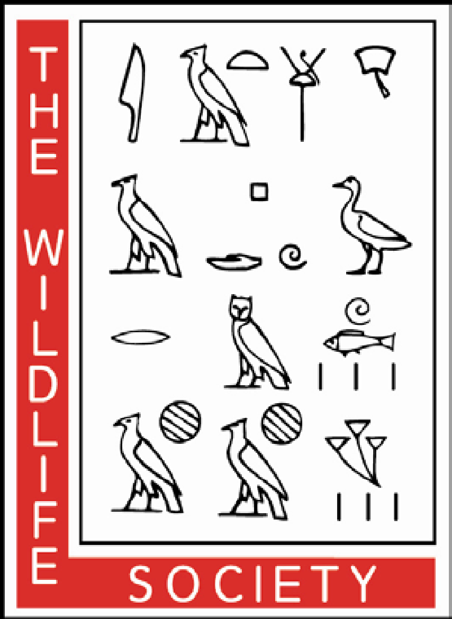
Wyoming Chapter – The Wildlife Society

Leaders in Wildlife Science, Management and Conservation

Graduate Student Scholarships Announcement

6 awards available
$750 each

Deadline for submission: 15 October, 2022
Introduction and Purpose: The mission of The Wyoming Chapter of the Wildlife Society is to inspire, empower, and enable wildlife professionals to sustain wildlife populations and habitats through science-based management and conservation. A key piece to achieving this mission is enhancing our members’ career development, which includes supporting graduate students and their research. Thus, WY-TWS is offering 6 graduate student scholarship awards in 2022. We look forward to reading your application!
Eligibility: To be eligible, applicants must be:
- A current WY-TWS member*
- A student in good standing and currently pursuing a graduate degree (MS or PhD).
- Applications will be judged on how they are contributing to scientific knowledge of wildlife, habitats, or human dimensions related to wildlife management.
- Applicants who are or have been active members of WY-TWS and/or TWS will be prioritized.*
- Applicants that have not previously received a WY-TWS Graduate Student Scholarship will be prioritized
Scholarship Application: Applicants must submit copies of the following materials:
- Attached application form (please fill out completely)
- Curriculum vitae
- Current graduate transcript (unofficial copy is ok)
How to Submit your Application:
- Please email completed applications with all materials in one file to Heather O’Brien, WY-TWS Board Member, at heather.obrien@wyo.gov by 15 October, 2022. Please include “WY-TWS Graduate Student Scholarship” in the subject line. Applicants will receive an email acknowledging receipt of their application.
- Scholarship recipients will be notified by 16 November 2022.
Responsibilities of Scholarship Recipient:
- Give a presentation of your graduate research at this year’s (2023) or next year’s (2024) WY-TWS Annual Meeting.
- Write a short article for the WY-TWS quarterly newsletter about your research or a related topic (coordination and timeline to be discussed with the newsletter editor).
- Allow your name to be released as a recipient of the WY-TWS Graduate Student Scholarship.

* To join the Wyoming Chapter of The Wildlife Society, visit our website http:/wildlife.org/wyoming-chapter/membership/

WY-TWS Graduate Student Scholarship Application Form
Please fill out this form completely and submit via email along with your resume or CV and a copy of your current graduate student transcript.

1. Applicant Information

Name:

Mailing Address (award check will be mailed to this address):

Daytime Phone Number:

Email Address:

Graduate Project Title:

Department and University:

Name of your Graduate Advisor:

Are you an M.S. or PhD Student?:

Anticipated Graduate Project Completion Date (month/year):

Have you previously received a WY-TWS Graduate Student Scholarship?

2. Abstract describing your research, its objectives, hypotheses, methods, preliminary results (if available). (Max. 400 words)

3. Describe how your research contributes to furthering the scientific knowledge of wildlife, habitats, or human dimensions and the relevance to wildlife management and conservation. (Max. 400 words)

4. Please describe your involvement with WY-TWS and/or TWS in the last 5 years(Max. 400 words)

