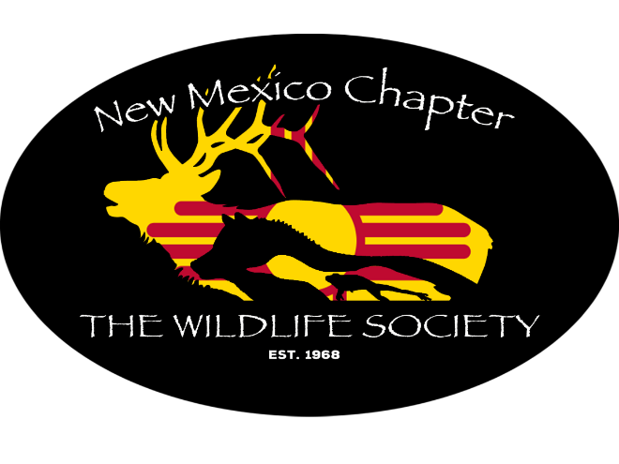
New Mexico Chapter of The Wildlife Society One-day Meeting
August 29, 2022

Location: Rotunda at UNM Science and Technology Park
801 University Boulevard SE, Albuquerque, NM

Parking is available only at the STP Parking Structure (see instructions)
Use the parking code for the day: 1932097

Agenda
8:00 Registration
8:30: Welcome and Announcements
9:00: Panel: Wildfire and Fish & Wildlife: how do we respond?
A panel composed of US Forest Service, NM Dept. of Game and Fish, US Fish and Wildlife and US National Park Service discuss how wildlife are considered while responding to and recovering from a wildfire event.
10:00: BREAK
10:15: Kathy Granillo, SW representative to the TWS Council, will talk on parent society activities, including diversity initiatives.
10:30: Quentin Hays, “Assessment of Sandhill Crane Exposure to Collision with Potential Transmission Lines along the Middle Rio Grande, New Mexico.”
10:45: Panel: What's happening with Wildlife Corridors in New Mexico
A panel composed of NM Dept. of Game and Fish and NM. Dept. of Transportation will be discussing the Wildlife Corridors Act and ongoing wildlife/corridors work.
12:00: Lunch will be provided.
Students will be given the opportunity to meet with professionals to discuss careers in wildlife conservation and management.
1:15: Giancarlo Sadoti, Nat. Heritage NM, “Improving Pinyon Jay Distribution Models by Addressing Scale and Local Habitat Variation.”
1:30: Anna Kirby, NMSU, “Effects of rabbit hemorrhagic disease virus 2 (RHDV2) emergence on population estimates of New Mexican lagomorphs”
1:45: Jenna Stanek, LANL, “Does Age, Residency, or Feeding Guild Coupled with a Drought Index Predict Avian Health during Fall Migration?”
2:00 Jessica Schlarbaum, “Wildlife trends reflected in admissions to New Mexico wildlife rehabilitation center.”
2:15: BREAK
2:30: Panel: Young professionals: opportunities for agencies and students alike
A panel composed of US Forest Service and NM Dept. of Game and Fish will discuss how some agencies are using internships and paid volunteers to meet their agency missions, and how students and young professionals might tap into such opportunities.
3:30: Door prizes and closing remarks
4:00: Unofficial social event off-site

Parking instructions
From University, turn West onto Basehart, then south on Bradbury Drive. The parking structure will be to the right (west). Enter the code and stall number to receive a ticket for the parking space. Code: 1932097. See the map below.
To find Rotunda, walk east and to the south of the office buildings east of the parking structure, cross the plaza and enter the next set of offices. The Rotunda will be at the end of the hall. See the map below.

