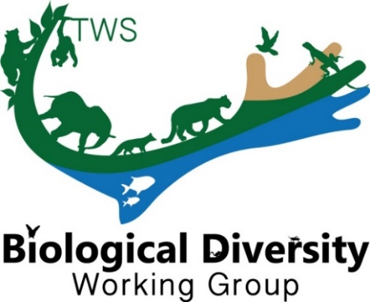
THE WILDLIFE SOCIETY
BIOLOGICAL DIVERSITY WORKING GROUP

The Biological Diversity Working Group (BDWG) is offering a Student Conference Grant (up to $100) to help a student attend the 2020 Virtual TWS Annual Conference! Be sure to apply no later than August 31st. Let us know if you have any questions.

Eligibility
All applicants must be a member in good standing with The Wildlife Society (but are not required to be a member of the BDWG) and have been accepted to present a paper/poster at the 2020 TWS Annual Conference. This is a merit-based award that will be scored based on the categories: 1) contact information, 2) abstract, 3) membership, 4) involvement, and 5) relevance.

**APPLICATION:
Submit application, as a Word or PDF file, directly to the BDWG (twsbdwg@gmail.com) no later than August 31, 2020. Place “Student Conference Grant” in the subject line of the email.

Contact Information
Date of Application:
Student’s Name:
Institution and Address:
Phone:
E-mail:
Abstract
Presentation Title:
Authors:
Current Category:
Presentation Type:
Abstract:
Membership (Please state if you [the student] are a current member of the Biological Diversity Working Group; BDWG membership is not required, but applications from a member will receive priority. You can join BDWG anytime via your TWS Member Portal.):
Involvement (Please explain how you plan to be involved with Biological Working Group Activities during the 2020 TWS meeting and beyond; for example attend the BDWG annual meeting and/or sponsored symposia/workshops, nominate yourself or others for a board position, interact on our Facebook page - https://www.facebook.com/BiodiversityWG/, etc):
Relevance (Please explain the alignment of the presentation and research with the mission and goals of BDWG; which can be found at our website- www.wildlife.org/bdwg):

Funding (Please list any secured or alternative potential sources of funding):

