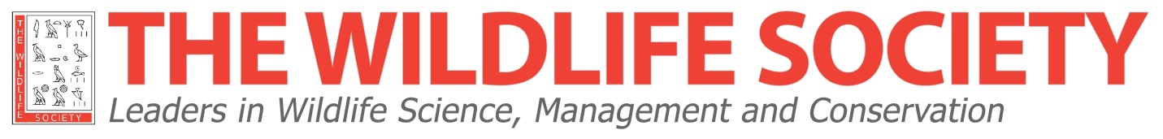
THE WILDLIFE SOCIETY
TAX REPORT FORM FOR YEAR: ____2019____

Insert Subunit Name:_________________

Insert Employer ID # (tax #)*: ________________

Please type all information and submit completed, electronic version via email

Beginning Balance 1 January 2019
_________

Income between 1 January and 31 December 2019
_________

Subtotal _________

Expenses between 1 January and 31 December 2019
_________

Balance as of 31 December _________

Did your organization unit spend any money on lobbying in 2019? Yes or no? _________
(Please refer to next page for a more detailed explanation)

______________________
Number of Current Members

____________________________________________________________________
Name (Please type) Officer Title

______________________________________________________________________________
Date Phone Number Email Address

THIS FORM MUST BE RETURNED NO LATER THAN 31 JANUARY

Mariah Simmons, Unit Services Manager
25 Century Blvd, Suite 505, Nashville, TN 37214
msimmons@wildlife.org 301-897-9770 x 310

Further details on lobbying question:
If your Chapter, Section, Student Chapter, or Working Group of The Wildlife Society (aka organization units) is included on The Wildlife Society’s group exemption with the IRS, this question will determine whether or not TWS Staff can submit the Form 990-N to the IRS on your behalf. If your organization unit did spend money on lobbying in 2018 then additional paperwork will need to be submitted to the IRS and TWS Staff will follow-up with more information.

