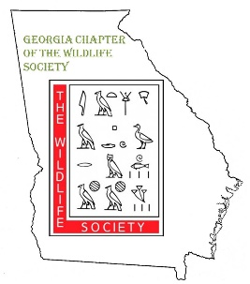Georgia Chapter of The Wildlife Society:
Student Travel Award Guidelines

The Georgia Chapter of The Wildlife Society (GA TWS) will offer travel grants for students to participate in the GA TWS annual meeting or The Wildlife Society (TWS) annual conference. These funds can be used for registration, transportation, meals, or lodging and will not exceed $250. Preference will be given to applicants who are active participants in GA TWS and who will be presenting a paper or poster at either meeting.

To apply, please email the application form below to lynn.lewis@usda.gov by August 12, 2019. Late applications will not be considered. Awards will be distributed at the GA TWS meeting or mailed to the address provided in the application after the GA TWS meeting.

Georgia Chapter of The Wildlife Society:
Student Travel Award Application

Name: Date:

Address:

Phone: Email:

College/University:

Degree Program: Expected Graduation Date:

TWS Conference to attend: Georgia Chapter Meeting National Chapter Meeting

Role at Conference (circle all that apply): Presenting Competing
Volunteering Attending Other:

If Presenting, indicate format: Paper Poster
Title:

Funding from other sources?
Source: Pays for: Registration Transportation
Hotel Meals
Source: Pays for: Registration Transportation
Hotel Meals

Are you a current member of the Georgia Chapter TWS (with paid dues)? Y N
Are you a current member of the National Chapter TWS (with paid dues)? Y N

Have you previously been awarded a GA TWS student travel award? Y N

Will you commit to writing a short article regarding your experience at the conference or a student spotlight for the GA TWS fall newsletter? Y N

Describe on a separate page using 250 words or less how attendance/participation at this meeting will be beneficial to your professional development.

