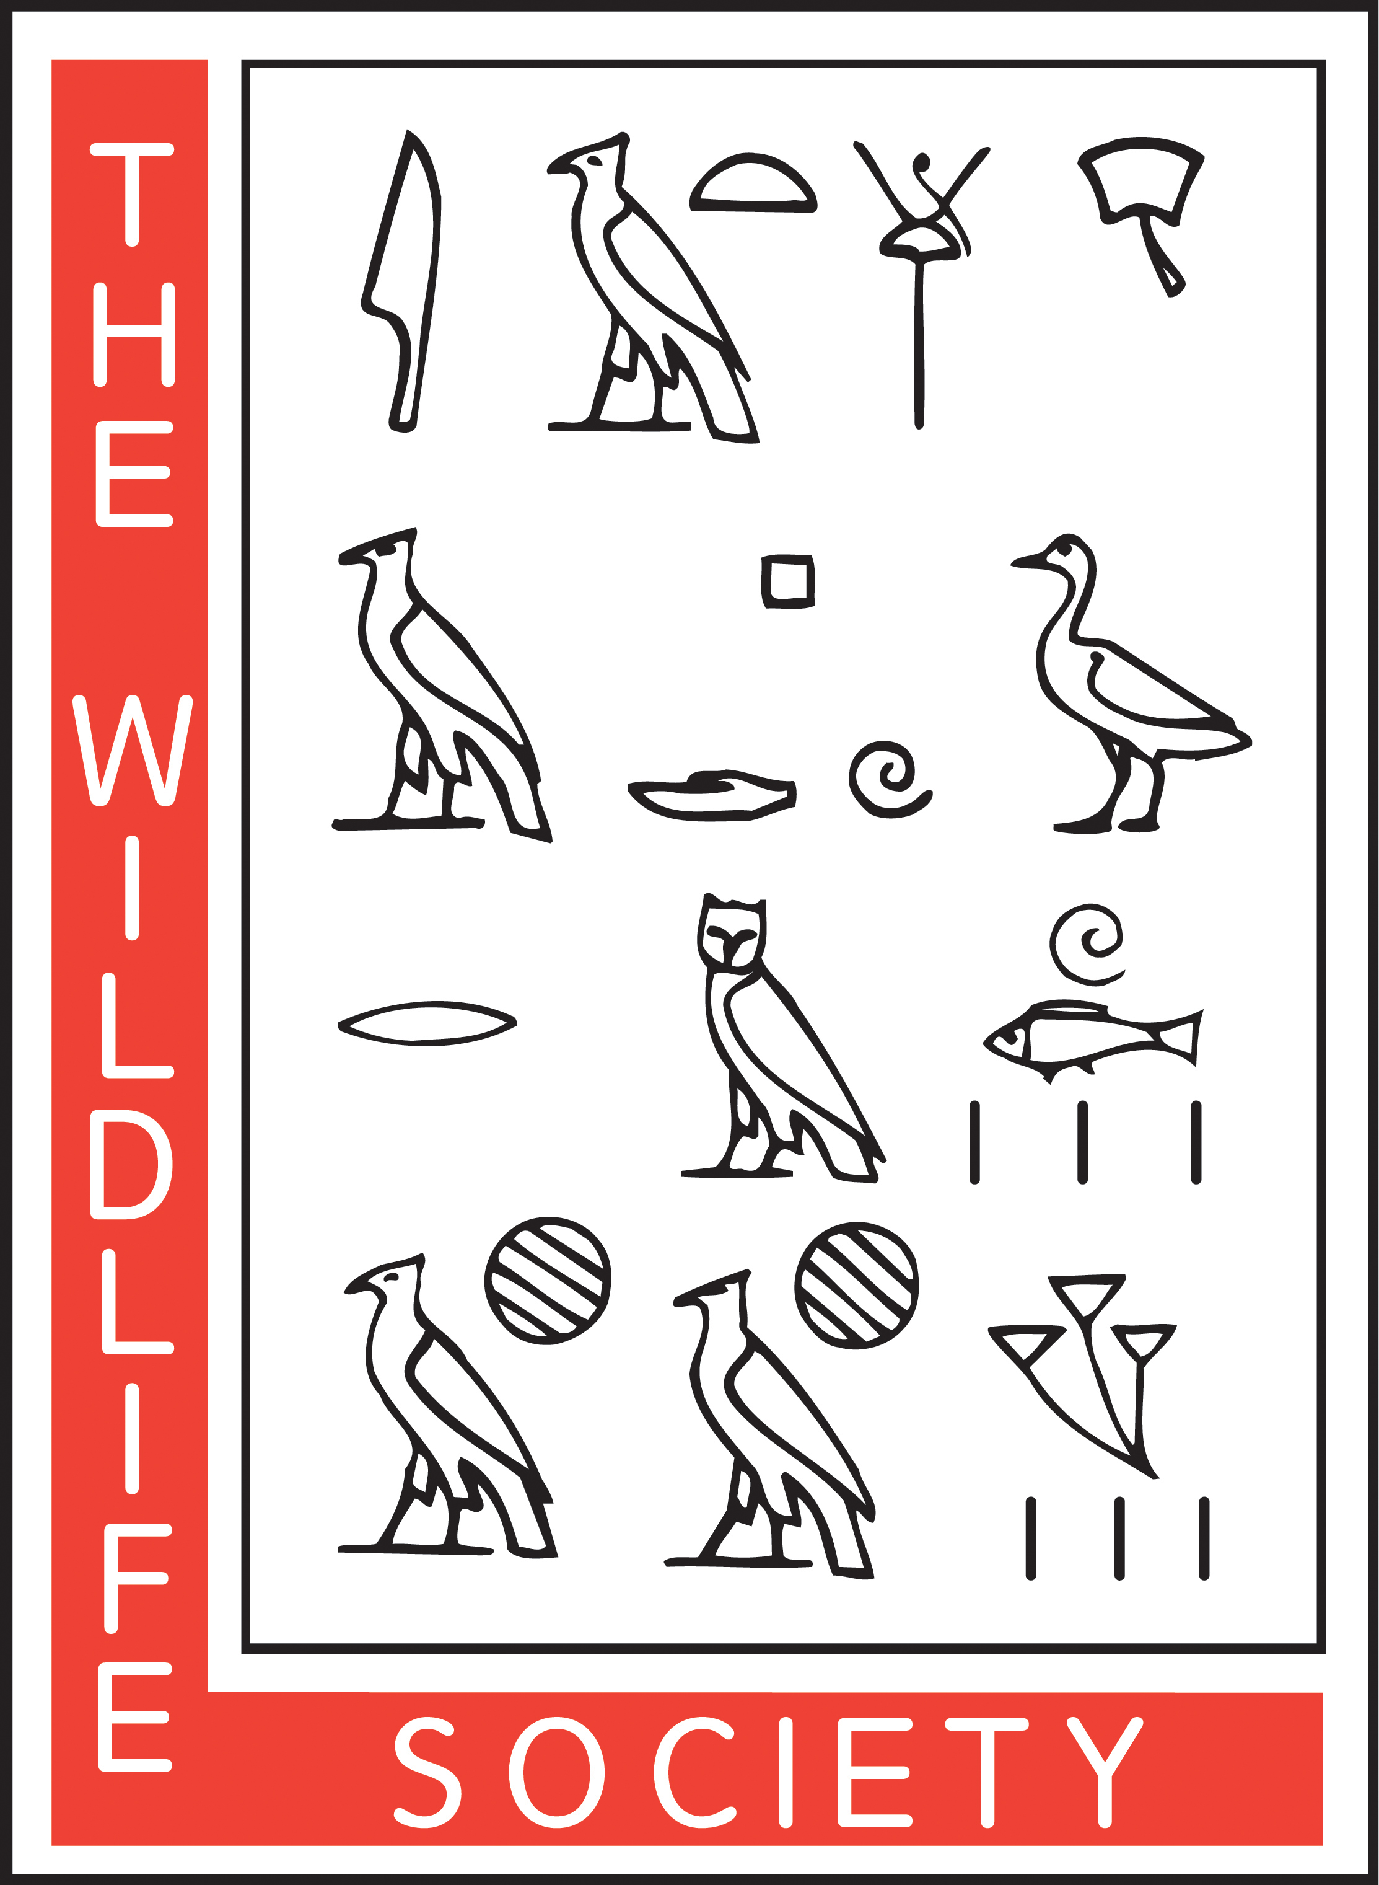
The Wildlife Society
Early Career Professional Working Group
Certification Assistance Scholarship Guidelines

Eligibility Requirements
- Preference will be given to a TWS Early Career Professional member.
- Applicant must have already gone through the Certification process and have been found to be lacking one course.

Outline of Grant Completion:
- Applicant will be notified of award no more than two months after application deadline.
- Recipient will register for the course that was approved of on their application.
- Once registered, recipient will send proof of course registration, associated costs, and contact information for the university’s billing office to the Early Career Professional Working Group.
- ECPWG will send a check to the applicant in the amount of $500. Should the course costs exceed that of the scholarship amount, the recipient will be responsible for paying the remaining funds.
- Once course is complete, recipient will send proof of course completion in the form of an unofficial transcript to the ECPWG board. Should the recipient not complete the course, provide proof of completion, or receive a grade that does not meet the requirements of The Wildlife Society’s Certification Review Board, the recipient will be responsible for reimbursing the Early Career Professional Working Group for the full amount of the scholarship.

Required Application Materials
- Application Form
- Essay
- Notice from The Wildlife Society’s Certification Review Board

Please submit your completed application to:

E-mail: ecpworkinggroup@gmail.com

The Wildlife Society
Early Career Professional Working Group
Certification Assistance Scholarship Application

First Name: Last Name:

Address 1:

Address 2:

City: State: Zip code:

E-mail:

Requirements to be met after Certification Board review:

Proposal for attaining requirements (Institute, online course, course name, course description, etc.):

Estimated timeline to meet requirements (Course semester, course completion date, etc.):

Estimated cost for course: $

Other funding sources (employer match, grant, private, etc.): $

Essay: Describe how receiving this scholarship will further your career, what you see as the value of Certification, your need for financial assistance, and how TWS has assisted in your professional growth. (500-750-word maximum).

