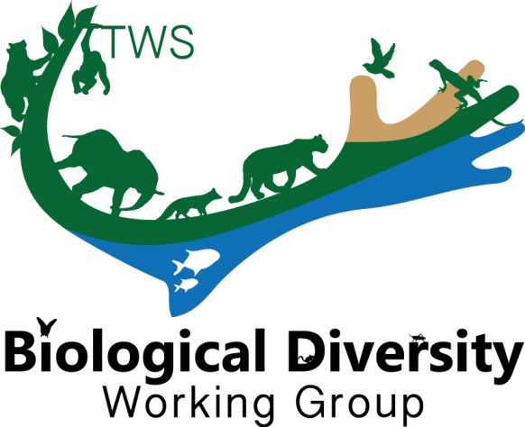
THE WILDLIFE SOICETY
BIOLOGICAL DIVERSITY WORKING GROUP

The Biological Diversity Working Group (BDWG) is offering a travel award to help a student attend the 2018 TWS Annual Conference in Cleveland, Ohio! Be sure to apply no later than August 31st. Let us know if you have any questions.

Eligibility
All applicants must have membership in good standing with The Wildlife Society and have been accepted to present a paper/poster at the 2018 TWS Annual Conference.

**APPLICATION:
This application is for a Student Travel Grant to support travel costs to the 2018 TWS annual meeting in Cleveland, Ohio.

Submit application directly to Angela Larsen (angelallarsen@gmail.com), BDWG Treasurer, no later than August 31, 2018.

Date of Application:
Student’s Name:
Institution and Address:
Phone:
E-mail:
Presentation Title:
Authors:
Current Category:
Presentation Type:
Abstract:
Biological Diversity Working Group Memberships of Authors:
Planned Involvement with the Biological Working Group Activities During the 2018 TWS Meeting and Beyond:
Secured and Alternative Potential Sources of Funding:
Alignment of the Presentation and Research with the Mission and Objectives of the Working Group:

