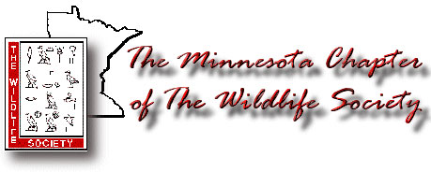
MNTWS Annual Elections Ballot - February 2015

President, Secretary and Treasurer – all members vote for ONE each

President
_____ Stephen Winter
_____ Write In: _____________

Secretary

_____ Maria Fosado
_____ Write In: _____________

Treasurer

_____ Lindsey Shartell
_____ Mandy Uhrich
_____ Write In: _____________

Regional Representatives –vote only for one candidate and only in your region
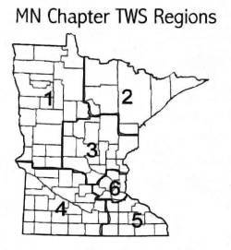
Region 2 Representative

_____ Bruce Anderson
_____ Lori Schmidt
_____ Write In: _____________

Region 4 Representative

_____ Lisa Gelvin-Innvaer
_____ Write In: _____________

Region 6 Representative

_____ Bill Severud
_____ Write In: _____________
(Josh Koelsch is no longer a candidate due to a job change and moving out of Region 6.)

Candidate information can be found in the December 2014 newsletter at
http://drupal.wildlife.org/minnesota/sites/wildlife.org.minnesota/files/MNTWS_2014DecNews.pdf
Ballots will be counted by the nominations committee, chaired by Jodie Provost, on Wednesday, Feb.18, 2015. Please return your ballots to the ballot box by 12 p.m. on Feb. 18, 2015. Absentee ballots can be sent electronically to Maria Fosado at mcfosa07@gmail.com or via mail at 617 North Union Avenue, Fergus Falls, MN 56537 and should be delivered no later Saturday, Feb. 14. Please include your name with your returned ballot so that the tellers will be able to assure one vote per person and voter’s chapter membership. Thanks!

