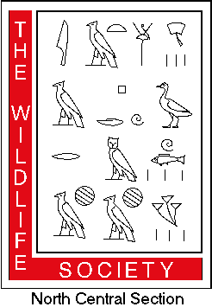
North Central Section
Illinois – Indiana – Iowa – Michigan – Minnesota – Missouri – Ohio - Wisconsin

The North Central Section (NCS) of The Wildlife Society has limited funds available each year to support member activities, continued education of members, and other professional development activities. Requests are accepted year round and can be submitted by completing the application below and submitting the request to an NCS Board Member.

ANNUAL FUNDING REQUEST

Event Date: Request Date:

Requesting Organization
Web Page URL (optional)

Organizational Contact:
Affiliation with Organization:
Address:
Phone: ( ) E-mail:

Brief (<200 words) description of the event:

How will this event benefit members of the North Central Section of The Wildlife Society? Please include an estimate of number of individuals impacted.

Amount Requested:

Other funding sources:

Have you received support from the North Central Section within the last 3 years? If “Yes”, when:

Application Deadlines: Oct 1, Feb 1, May 1.

