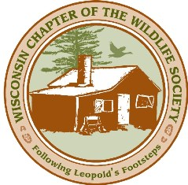
Call for Abstracts

DEADLINE EXTENDED TO DEC 10th

Wisconsin Chapter of The Wildlife Society Winter Meeting 2019

WCTWS is looking for interesting presentations and posters for our annual winter meeting being held February 12-14, 2019 at the Stoney Creek Inn in Rothschild, WI. The theme of this year’s meeting will be “Building Strength From Within”.

The conference agenda includes two plenary sessions, the WCTWS business meeting, committee meetings, a banquet, fundraiser, and plenty of time to network with your fellow wildlifers.

There will be several concurrent sessions for you and your colleagues to give 20-minutes presentations or share your work in a poster session. We are seeking submissions on a variety of topics including research, policy, education, management, professional development, or partnerships.

The NEW deadline for abstracts is December 10, 2018. When submitting, please include the following information in a Word document or PDF:

1. Title of Presentation:

2. Oral presentation or Poster

3. Your name:

4. Abstract (200 words or less):

Questions or Submissions can be emailed to Robert Holsman at robert.holsman@Wisconsin.gov

