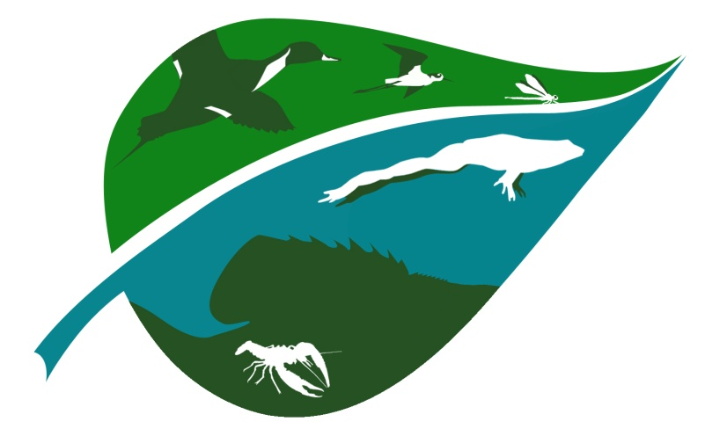
Wetlands Working Group
The Wildlife Society

January Meeting MInutes
January 26, 2017 – 1 pm CST
Attendees: Jennifer Chutz, Adonia Henry, Johanna E. Duffy

- Admin
- WWG non-compliance notice - resolved within 1 day. All officers have up to date memberships.
- Officer Report due 1/31/17 - DONE (Adonia 1/4/17)
- Tax Form due 1/31/17 - DONE (Auriel 1/25/17)
- TWS Working Group Communications Ad Hoc Committee" (Harriet Allen - Chair)
- Created by TWS President Bruce Thompson
- Intended to enhance substance and timeliness of information communicated to Working Groups about requests they have submitted for Council consideration.
- TWS Council Government Affairs and Partnerships (GAP) Policy Priorities Liaison Ad Hoc Committee - PAST DUE (1/22/2017)
- "Our charge is to develop a list of policy priority recommendations for GAP staff that Council will act on at our March meeting. We believe that reaching out to TWS Working Groups provides a way for our committee to interact with a good cross section of TWS members on this important topic. The approved list will serve to focus GAP activities for the next 2 years during the 115th Congress. Please keep in mind, the final list will be those items where TWS would take a lead role. So this list of priorities will not affect ongoing or any new activities GAP staff may take on, given staff capacity, where TWS takes a subordinate role, i.e. signing on to letters, monitoring activities of other groups, etc..."
- Request to Council Action Format - DUE 2/3/17
- " A status report from each of you on your activities is requested. If you require any guidance from Council or have any actions for Council to consider, it is important that you provide a recommendation to Council specifically describing the actions being requested and outline any potential budgetary or financial implications."
ACTION ITEMS:
- Adonia - Annual Report - DUE 1/31
- Adonia - Request to Council Action - DUE 2/3/17. Resubmit the info from 9/9/2016 that Adonia submitted about “Alterations of Stream, Riparian, and Wetland Habitats in the U.S." Position Statement (see below)

- Treasurer Report
- Auriel still looking into online checking account to reduce issues with getting checks cashed, etc.
ACTION ITEMS:
- Adonia - Will call US Bank to make sure the terms will work for us and that it's easy to transfer to each new Treasurer
- Jen - If it does work, physically set it up in Montana.
- Auriel - Did the $275 check for student award clear (late October)?
- Auriel - Did Heath's check closing Regions Bank acct. get deposited (late November)? - NO

- Membership
  - New roster posted for January - 113 members (112 + me)

- Media
- Logo
- Email from Mariah Simmons on 1/17/17: "2016 Fall Council meeting in Raleigh, NC, Council expressed concerns over some Working Group logos not including TWS identity in their logo designs. Council considers these logos to be insufficient because they don’t incorporate identity of TWS. Therefore, please ensure that all current and/or future logos include either the name “The Wildlife Society” or the TWS logo."
ACTION ITEMS:
- Jen - Email Mariah to make sure our logo is OK. It has both "Wetlands Working Group" and "The Wildlife Society".
- Adonia – add TWS to the logo with text along edge of leaf
- Website
- Email Mariah Simmons at msimmons@wildlife.org to update website
ACTION ITEMS:
- Jen - Create Google Drive folder to archive old stuff from old website (they only migrated 2013 forward). Use WWG email. Create folder called TWS Docs & Deadlines for documents like Annual Reports that continue to recur.
- Jen & Adonia - Compile links to other sources of wetland news instead of maintaining our own monthly update in "Wetland News" section. Get onto website.
- Johanna - Add "training opportunities" section
- Newsletter
- Distributed December 2016 Newsletter on 1/6/17 - already up on website
- Going to 2/year
- Adonia will continue to format newsletter, not write articles
- Next issue will be July pub date - deadline for articles is June 16.
ACTION ITEMS:
- Adonia - Knows someone who might write a feature article on herps for July issue
- All – Think of folks who could write future feature articles
- Other "fill in" articles - send ideas to Adonia. We will divvy these up amongst Jen, Auriel, and Johanna to write as the deadline nears.
- Adonia - Continue with "training opportunities" and “wetlands in the news” section
- Facebook
- 20 members
ACTION ITEMS:
- Adonia - Post December newsletter
- Adonia - Get Johanna admin access
- All - Don't forget to post pertinent articles!
- Jen - Write email/FB post/website post to get Social Media Liason to keep our page updated.
- Email
- Adonia created a general WWG email account at wwg.tws@gmail.com
- Membership Survey
  - Some members were very interested in certain topics
  - Could set up members as ‘Liasons’ on certain topics so they can update the board on that particular issue and take a lead if the working group decides to do something in that area, i.e., Auriel is liason with SWS Wildlife Group
ACTION ITEMS:
- Jen - In same email/FB post/website post, see if there's any interest in folks being these "Liasons"
- All - Send Jen any articles/policy info/research info to compile for more frequent email blasts to increase communication with membership, as requested at 2016 Natl. Mtg.
- Adonia - Will compile final Membership Survey results for next meeting
- Webinars
- Suggested at 2016 National Mtg by members
- Seems improbable - for example, ASWM can produce webinars b/c they have full time dedicated staff, our board is volunteers

- TWS Conservation Affairs Network
- Currently Jen, Adonia & Scott Yaich receive these. Does anyone else on the board want to replace Jen/Adonia as new Board Member recipient?
- From Keith Norris: "Please let me know if the CAN contact for your Chapter, Section, or Working Group has changed. This newsletter is generally distributed to only one CAN Contact within each organizational unit (unless you have instructed me to do otherwise), so please distribute to others as you see fit and let me know if someone else should be the primary contact for this effort."
- This person reads through the CAN to see if there's anything pertinent to our membership and coordinates with Scott Yaich, who helps with this task and gives his thoughts.
ACTION ITEMS:
- Jen - Send to Johanna to see if she's willing to be the main contact along with Scott
- Adonia – Email Scott to see if he’s continuing with TWS CAN after he retires.

- Editorial Advisory Board
- Jen was the representative for 2 years, ending Dec 31, 2016.
- WWG is NOT required to have a rep. for next 2 years, but it can have one if someone wants it. 6 conf calls/year, review ideas/topics for The Wildlife Professional, review several articles/year.
- WWG will wait until it is called upon again, potentially in 2 years, to serve on the EAB.

- TWS Position Statement - “Alterations of Stream, Riparian, and Wetland Habitats in the U.S."
- WWG would like to provide technical expertise to review and revise as necessary this TWS position statement. With the advances in wetland science over the past 8 years and recent court decisions, we think it is important that this position paper be updated.
- Was approved by council September 2009 and expires October 2017 (pushed back from Oct 2016 expiration)
ACTION ITEMS:
- Jen - Put this on the Request to Council (see above)

- TWS partnership with Bayer Bee Care
ACTION ITEMS:
- Jen - Ask Bryce/Dan about this
- Adonia - Continue to look into concerns by TWS member about use of science by Bayer.

- 2017 TWS National Meeting - Sept 23-27, Albuquerque, NM
- Suggestions from Members
- Field Trip
- B/w cost of bus and other costs, which we have to cover up front, we don't have the $.
- Not feasible at this time
- Organizing symposium on Water, Wetlands and Wildlife
- Did we include notice in newsletter? YES
- Sammy King is willing to do it, Adam Janke is willing to help
ACTION ITEMS
- Adonia - Follow-up with Sammy and Adam about it
- Group booth for ALL 29 Working Groups
- Push this idea
- Can any of the 4 of us attend the National Mtg?
ACTION ITEMS
- Adonia will follow up.

- 2018 Arid Wetlands Symposium
- Partnering with SWS Wildlife Section
ACTION ITEMS
- Auriel – Keep up-to-date with SWS Wildlife Section planning for symposium
- Auriel - Any interest from people wanting to be a part of this?

- Next meeting at 1PM CST on 2/23/2017

Minutes prepared by: Jen Chutz

