Oklahoma Chapter of The Wildlife Society Membership Form

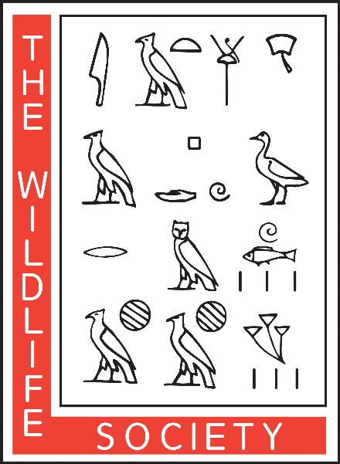

Please print, complete and mail this page with your check to:
Michael Sams
C/O TWS
347260 E. 830 Rd.
Stroud, OK, 74079

Name

Affiliation (agency, university, company, etc.)

Address

City, State, ZIP

Phone number

Email address

$_______Regular Membership ($10 per year)
$_______Student Membership ($5 per year)
$_______Supporting Membership with number certificate
($100 per year)

