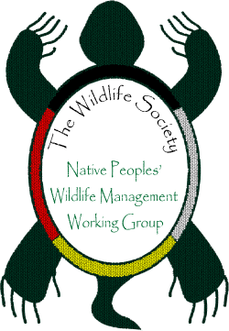
The Wildlife Society
Native Peoples Wildlife Management
Working Group

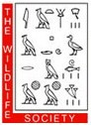
Native Student Professional Development Program
Winnipeg, Manitoba Canada
October 17-21, 2015
Final Report

Summary of Objectives and Accomplishments:
As a scientific organization for professionals who manage and conserve wildlife and habitats, The Wildlife Society (TWS) is increasingly concerned about the lack of ethnic and cultural diversity within the profession. Diversity is essential if the profession is to grow and meet the nation’s conservation challenges. To help address this concern, TWS established a professional-development program for Native students studying various aspects of natural resource management.

The indigenous community has enormous potential to enrich diversity within the wildlife profession. Native lands often consist of important wildlife habitat, and indigenous students are showing a growing interest in pursuing careers in wildlife management and conservation. Furthermore, Native American and other indigenous cultures rely heavily on wildlife resources as a source of income, basis for their culture, and subsistence living. TWS has an active Native Peoples’ Wildlife Management Working Group (hereafter, Working Group or NPWMWG) composed of wildlife professionals and students, tribal and non-tribal, who recognize native people’s cultural, spiritual, and ecological connections to the land. TWS and the Working Group have been exploring ways to promote the early development of indigenous wildlife professionals.

TWS believes one of the most-effective ways to support indigenous wildlife students is to give them an opportunity to attend and participate in TWS’s Annual Conference – the largest gathering of wildlife professionals in North America. In 2008, TWS, with support from multiple federal agencies, implemented a competitive Native Student Professional Development (NSPD) Program. Individuals selected for this program receive grants of $1,500-$2,500 each to help cover registration fees, lodging, meals and transportation to attend and participate in the annual conference. Program participants also receive a one-year membership in TWS and become members of the TWS Native People’s Wildlife Management Working Group. As TWS members they receive the quarterly member magazine The Wildlife Professional, the monthly electronic newsletter The Wildlifer, discounts on TWS peer-reviewed publications such as The Journal of Wildlife Management and Wildlife Society Bulletin, and access to the TWS website, blog, career center, mentoring program, and other online resources.

The purpose of this APHIS grant was to provide Federal financial assistance to fund a symposium or provide funds for competitive students to participate in The Wildlife Society’s 22nd Annual Conference in Winnipeg, Canada, October 17-22, 2015.

Eligibility:
Candidates must be members of a Native American, First Nations, or indigenous tribe, and currently enrolled in an undergraduate or graduate program in a relevant academic discipline such as wildlife biology or ecology. Applicants must display a record of academic excellence and a strong interest in pursuing a career in wildlife management or conservation.
Application:
Flyers for the Professional Development Program (see Figure 1: attached PDF) were sent out on 19 April with a due date of 1 August 2015.
Selection:
Qualified applicants are evaluated by a panel consisting of the Chair of the Native Peoples’ Wildlife Management Working Group, two other working-group members, a TWS staff member, the Professional Development Program Coordinator, and at least one representative from other program partners, including the Native American Fish and Wildlife Society.
This year, the Native People’s Wildlife Management Working Group had funding for seven students to attend this year’s conference. Serra Hoagland, a past recipient, is the Professional Development coordinator.
2015 Native Student Professional Development Program participants:
- Valentine Vaeoso (Pacific Islander), Undergraduate at University of Hawaii at Hilo
- Laura Lagunez (Navajo), Undergraduate at Cornell University
- Victoria Atencio (Santa Domingo Pueblo), Undergraduate at New Mexico State University
- La'akea Low (Native Hawaiian), Undergraduate at University of Hawaii Maui College and Oregon State University Ecampus
- Chase Voirin (Navajo), Master’s student at University of Arizona
- Bronson Palupe (Native Hawaiian), Undergraduate at University of Hawaii at Hilo
- Megan Judkins, PhD student at Oklahoma State University
Honorary
- Vernon Nieto (Santa Domingo Pueblo), Undergraduate at New Mexico State University

Native Student Professional Development Program
The Wildlife Society 22nd Annual Conference
October 17-21, 2015, Winnipeg, Canada
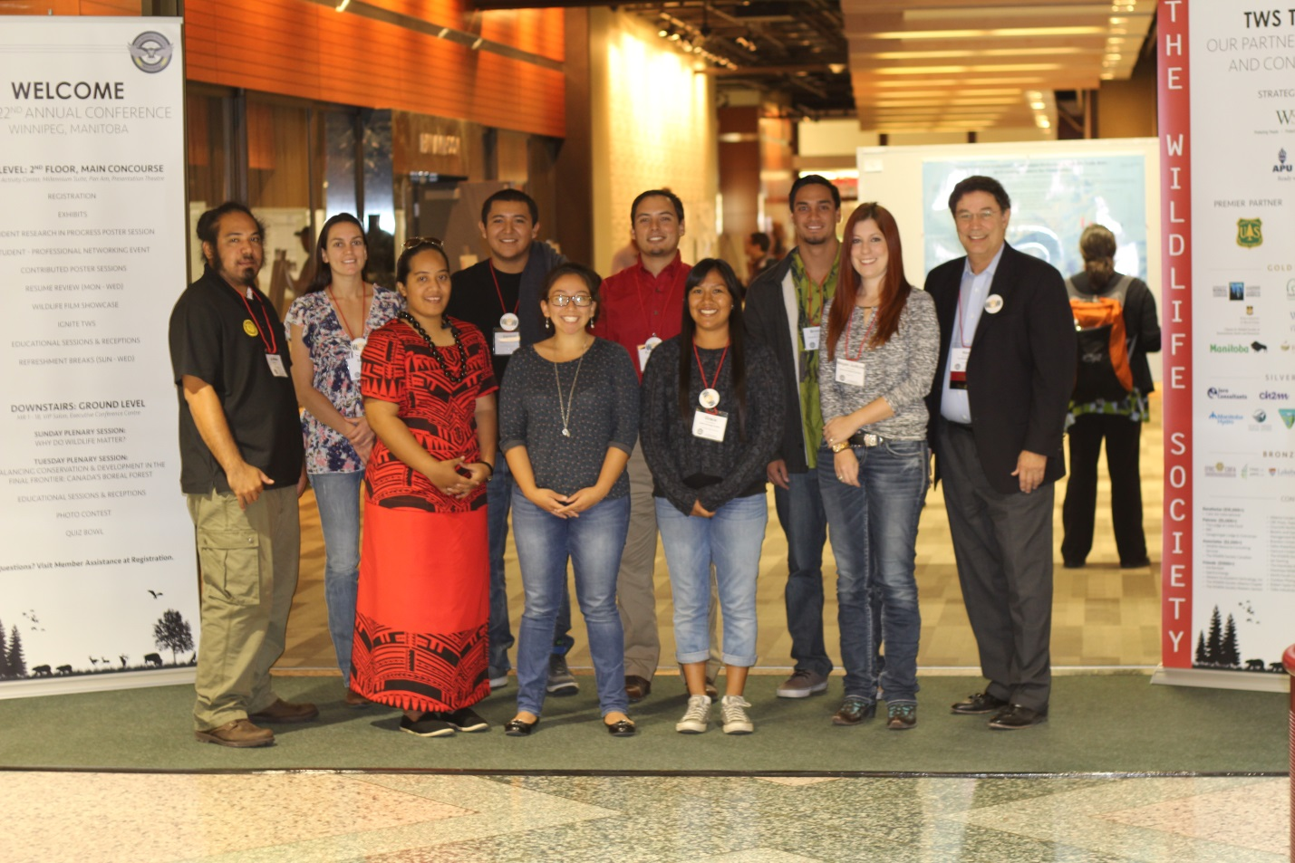
Native People’s Wildlife Management Working Group-Post Meeting-October 2015
Professional Development Coordinator, students, and TWS Executive Director
Left to right front row: Valentine Vaeoso (Pacific Islander) Undergraduate at University of Hawaii at Hilo, Laura Lagunez (Navajo) Undergraduate at Cornell University, Victoria Atencio (Santa Domingo Pueblo) Undergraduate at New Mexico State University.

Left to right back row: La'akea Low (Native Hawaiian)-Undergraduate at University of Hawaii Maui College and Oregon State University Ecampus, Serra Hoagland (Laguna Pueblo)-PD Program Coordinator and PhD Candidate at Northern Arizona University, Vernon Neito * (Santa Domingo Pueblo) *Honorary member of NSPD*-Undergraduate at New Mexico State University, Chase Voirin (Navajo)-Master’s student at University of Arizona, Bronson Palupe (Native Hawaiian)-Undergraduate at University of Hawaii at Hilo, Ken Williams-Executive Director of The Wildlife Society.

Professional Development students had a number of requirements to fulfill as part of their attendance at the meeting. Prior to the conference students participated in several Skype meetings with other grant recipients to prepare them for their experience, introduce them to their cohorts and answer any questions related to the conference events. Upon arrival, students attended the Student and the New Member’s Receptions where they met with other students from other universities and fellow new attendees. Students attended two working group meetings, were introduced to several Student Conservation Association (SCA) opportunities, and various organizations, companies and agencies at the trade show exhibit booths. Professional Development grant recipients also participated in the Student-professional Mixer where they interacted with hundreds of professionals that work throughout North America. Students also had the opportunity to meet and network with members of TWS Council on and actively participated in the symposium sponsored by the Native Peoples Wildlife Management Working Group. During the Native Peoples Wildlife Management Working Group (NPWMWG) annual meeting, several PD students volunteered to help organize for the 2016 NPWMWG sponsored symposium. It is apparent that students who have participated in this program are interested in remaining active in the Wildlife Society, our NPWMWG, advancing their professions, and sharing their experiences with their communities.
At this year’s conference, the NPWMWG co-sponsored a symposium on October 19th, entitled: “Indigenous Peoples Involvement in Wildlife management.” The symposium included presentations by a variety of First Nation and indigenous speakers, and a Panel Discussion. This was a well-attended symposium, especially by The Wildlife Society (TWS) leadership.
The NPWMWG held its working group meeting on Wednesday afternoon. This was attended by thirty or more members and interested participants. Discussions by the group included a number of topics. The group has been invited to write a chapter on Traditional Ecological Knowledge (TEK) for the Wildlife Techniques Manual revision, slated for re-publication in 2017. There were discussions on reaching out membership to tribal wildlife managers, liaisons to federal and state governments, and the Native American Fish and Wildlife Association (NAFWA). The group also organized a committee to put together a symposium proposal for next year’s annual meeting in Raleigh, North Carolina.

List of partners:
Supporting agencies include the Western and Canadian sections of The Wildlife Society, the U.S. Fish and Wildlife Service and the USFWS National Wildlife Refuge System, the U.S. Forest Service, the U.S. Department of Agriculture’s Animal Plant Health Inspection Service (Wildlife Services program and Civil Rights Enforcement and Compliance Unit), U.S. Department of Agriculture APHIS Wildlife Service’s National Wildlife Research Center, the U.S. Geological Survey, and the U.S. National Park Service.

Acknowledgements:

We would like to extend a special thank you to Dr. Elizabeth Flaherty, and Dr. Patrick Zollner of Purdue University, as well as The Wildlife Society, especially Jonathan Haufler, Ken Williams, and Jane Jorgensen.

Final Report Prepared by:
Serra Hoagland – Native Peoples Wildlife Management Working Group, Professional Development Program Coordinator
Daniel N. Gossett – USDA/APHIS/WS/NWRC, NPWMWG member.

For more information:
Name: Serra Hoagland
Affiliation: Program Coordinator, Native Student Professional Development Program
Phone: 928-556-2190
Email: serrahoagland@gmail.com
Date: 8 December 2015

Figure 1: Professional Development Program Application Flyer

